STATISTICAL ANALYSIS ABOUT GOLD AND PLATINUM PRICES IN TAMIL NADU

Project work submitted to the Annamalai University in Partial fulfilment of the requirement for the degree of

# MASTER OF SCIENCE IN STATISTICS

Submitted by

KANNAN.M

REG. NO: I19170005

Under the guidance of

Dr.P.PANDIYAN, M.Sc., M.Phil., Ph.D.

Professor of Statistics

# ANNAMALAI UNIVERSITY

DEPARTMENT OF STATISTICS

ANNAMALAI NAGAR - 608002

2023-2024

ANNAMALAI  UNIVERSITY

DEPARTMENT OF STATISTICS

# **CERTIFICATE**

This is to certify that the project work entitled “STATISTICAL ANALYSIS ABOUT GOLD AND PLATINUM PRICES IN TAMIL NADU” is the work done by the candidate Mr. KANNAN.M bearing the Register Number I19170005 in partial fulfilment of the requirements for the award of the degree Master of Science in Statistics during the year 2023-2024.

**Project Guide** **Head of Department**

Dr. P. PANDIYAN Dr. P. PANDIYAN Professor Professor and Head

Department of Statistics Department of Statistics

Annamalai University Annamalai University

Place: Annamalai Nagar

Date:

ACKNOWLEDGEMENT

First and foremost, I would like to express my sincere and deep hearted indebtedness to Dr. P. PANDIYAN, Professor and Head, Department of Statistics, Annamalai University for his encouragement and for his valuable advice to complete this project work.

1 thank my project guide Dr. P. PANDIYAN, Professor of Statistics, Annamalai University, for the golden opportunity to do this wonderful project on the topic ‘STATISTICAL ANALYSIS ABOUT GOLD AND PLATINUM PRICE IN TAMIL NADU', by doing which I learnt so many new things in research.

Secondly, I thank my PARENTS who supported my studies from the beginning and my FRIENDS and CLASSMATES who helped me a lot in finalizing this project within the limited time frame.

Next, I express my sincere thanks to all the teaching staff members of the Department of Statistics for their valuable suggestions to complete this project successfully.

(KANNAN.M)

# CONTENTS

# 

|  |  |  |
| --- | --- | --- |
| CHAPTER NO. | TITLE | PAGE NO. |
| I | INTRODUCTION |  |
| II | OBJECTIVES |  |
| III | METHODOLOGY |  |
| IV | STATISTICAL ANALAYSIS |  |
| V | SUMMARY & CONCLUSION |  |
| VI | APPENDIX |  |

CHAPTER-I

INTRODUCTION

**Metals** are the naturally occurring compounds of the earth found below the surface in the form of ores. They can be found in rocks also, and they **comprise 25%** of the earth's crust and are used around us in our daily lives.

Gold, silver, lead, iron and brass were also in use in the **5th millennium BCE**. They are very strong and durable substances and thus used for manufacturing automobiles, satellites, cooking utensils, the framework for skyscrapers, etc. They possess properties such as malleability, and ductility and are sonorous besides being good conductors of heat and electricity.

## Metal Definition Chemistry

The chemical **definition of metal** can is that it is highly dense, malleable, and ductile and can form alloys with other metals and nonmetals, some react with air and corrode, for e.g. iron. They are good conductors of heat and electricity, for e.g. silver. Metals are solid at room temperature, except mercury is in a liquid state.

## Types of Metals

Metals can be classified in a number of ways:

**1. Classification by Iron Content -** When a metal contains iron it is called a ferrous metal and imparts magnetic properties to a substance, metals which don't have iron content are non-ferrous metals and do not possess any magnetic properties. Examples are aluminium, brass, copper, etc.

**2. Classification on the Basis of Atomic Structure -** According to its placement in the Periodic table, a metal can be alkaline, alkaline earth or transition metal.

**3. Magnetic and Non-Magnetic Metals -** Ferromagnetic metals strongly attract magnets, paramagnetic metals exhibit weak attractions and diamagnetic metals exhibit a weak repulsion to magnets. Certain metals are most suitable for certain applications depending on their cost, safety factor, electrical conductivity, density, etc.

## Metals in Periodic Table

The metals are classified in the periodic table by their placement in it. They lose electrons fairly easily but gain them with difficulty. They possess few valence electrons and can form positively charged cations.

* **Alkali Metals:**

These are found in the first column on the left side of the periodic table. They are soft, highly reactive, and possess one electron in their outer subshell, examples are lithium, sodium, potassium, and rubidium.

* **Alkaline Earth Metals:**

These have two electrons in their outermost subshell, they each make a distinctive colour with their flames. Examples are beryllium, magnesium, calcium, strontium, barium, and radium.

* **Transition Metals:**

These are found in the centre of the main periodic table; they are also called heavy metals and are denser than any other metals. There are 38 Transition Metals including cobalt, copper, gold, iron, mercury, silver, tungsten, titanium, zinc, etc. Other than them, there are inner transition (f-block) elements also.

## Metal Elements

Most of the elements in the periodic table are metals, for example iron, copper, silver, mercury, gold, nickel and tin. **Around 92 of 118** elements are metals; the accuracy sometimes differs because boundaries between metals, non-metals and metalloids are blurry. Metals are good conductors of electricity and heat, they have a high melting point, and apart from being malleable and ductile, all these properties nonmetals lack. Metalloids fall between metals and non-metals in appearance and properties.

## Examples of Metals

**Metals** are found on the left side of the periodic table, they consist of alkali metals, alkaline earth, transition metals, lanthanides and actinides. Over **75% of elements** are metals and fill most of the periodic table.

Iron, zinc, titanium, aluminium, silver, gold, copper, platinum, manganese, lead, tin, mercury, cobalt etc. are some examples of metals. Iron is present in abundance in the earth's crust, it's ductile and hard and through alloying with carbon we obtain steel. Aluminium is used amply in industrial, iron and steel trades because of its low density and good resistance to corrosion.

## Metal Chemical Formula

When a metal reacts with oxygen, metallic oxide is formed. For example, magnesium reacts with oxygen to form magnesium oxide.

* The **chemical formula** of metal oxide is **MxOy**.
* The **chemical formula** for copper(I) oxide is **Cu2O**.
* The **chemical formula** for aluminium bromide is **AlBr3**.
* The **chemical formula** for iron(III) chloride is **FeCl3**.

## Metals and Their Properties

**Metals** react with non-metals to form ionic bonds for eg. sodium chloride, metals have high melting and boiling points, they are lustrous, they are hard so are used in making buildings, ships etc.

## Interesting Facts

* The Eiffel tower in Paris, France is made of wrought iron.
* When tin is bent to produce a particular shape it emits a peculiar sound known as a **'tin cry'**.

## Key Features of Metals

* **Metals** are the naturally occurring element of the earth found below the surface in the form of ores.
* Metals are lustrous and possess malleability and ductility.
* Over **75% of elements** are metals and fill most of the periodic table.

GOLD**G**

## Chemical Properties of Gold

|  |  |  |  |
| --- | --- | --- | --- |
| Group | 11 | Melting point | 1064.18°C, 1947.52°F, 1337.33 K |
| Period | 6 | Boiling point | 2836°C, 5137°F, 3109 K |
| Block | D | Density (g cm−3) | 19.3 |
| Atomic number | 79 | Relative atomic mass | 196.97 |
| State at 20°C | Solid | Key isotopes | 197Au |
| Electron configuration | [Xe] 4f145d106s1 | CAS number | 7440-57-5 |
| ChemSpider ID | 22421 | ChemSpider is a free chemical structure database | |

## What is Gold?

* Gold is a soft bright, dense, soft, malleable, and ductile metal with a slightly reddish yellow colour when available in mass. But when divided finely it becomes black, purple or ruby.
* Being one of the most malleable and ductile metals, 28g of gold can be beaten into 300 square feet of it.
* A major share of this soft metal is mined and is handed to us as gravels or quartz veins or pyrites deposits.

## Uses of Gold

* The metal is mainly used to manufacture jewellery, glass and different parts in electronics items.
* Gold can be made into thread and used in embroidery.
* A thin layer of this metal is used on the windows of a large building for reflecting the heat of sun rays.
* Gold is also used in medicine. Its radioactive isotope Au-198 is used for the treatment of the tumour.

## Properties of Gold

* Being very good conductors of heat and electricity, the metal does not get affected by air and most reagents.
* The element is corrosion resistant and is present in deposits of alluvium and veins.
* Most common gold compounds include chloroauric acid and auric chloride.
* To provide more strength to the metal, another soft metal is alloyed to it.

## Certain Facts About Gold

* The metal consumes around 75 % of the jewellery across the world.
* The element is abundant on the planet at 0.03g per 1000kg background level.
* The atomic symbol of gold ‘Au’ comes from the Latin word “aurum”.
* A gold layer (thin coating) is done on astronaut helmets to protect them from UV radiation.
* The price of the metal is determined through trading in gold.

PLATINUM

## What is Platinum?

* Platinum is an element with the atomic number 78 and an atomic mass of 195 in the periodic table. It is an extremely rare element found in the crust of the earth.
* The word Platinum is derived from Platina (Spanish word meaning ‘little silver’), because of its grey-white silvery colour. With availability of 5 g/kg in the earth’s crust, it is one of the rarest elements and is highly valuable for the same reason. Although it was discovered relatively later by European scientists, it has been found in Egyptian tombs dating back to 1200 BC.

## Uses of Platinum

* It is used in laboratories for electrodes.
* Optical fibres, wires, and pacemakers also make use of platinum for better efficiency.
* Certain compounds of platinum are used in chemotherapy for treating cancer.
* Some watchmakers use platinum in their watches to make them exclusive.
* Because of its stable physical and chemical properties, **platinum metal** is a very useful metal. Despite its rarity, its application is quite widespread.
* Because of its high stability, platinum is used extensively as a catalyst for chemical reactions.
* The most common application of this is the Catalytic Converter in cars which converts the Carbon monoxide (CO) and other residual pollutants into Carbon dioxide (CO2) and water vapour.
* The high malleability, ductility, and inertness of the metal make it suitable for making jewellery especially. Around half of the platinum extracted every year goes into making jewellery.

  
Uses of Platinum

## Properties of Platinum

* Physically, platinum is a soft, lustrous, silver-coloured metal.
* It is highly dense (21.5 g/cc), malleable and ductile (there is an ongoing debate if it is the most ductile).
* It is also highly corrosion resistant and has a high boiling point ( around 1700 degrees Celsius or 3220 degrees Fahrenheit).
* Chemically, platinum is one of the most stable elements in nature. It is often referred to as Noble metal because of its high stability.
* It is immune to nitric and hydrochloric acids but can be dissolved by aqua regia at a high temperature.
* It reacts with oxygen and fluorine but at very high temperatures. Platinum has six isotopes that occur in nature-  190Pt, 192Pt, 194Pt, 195Pt, 196Pt, and 198Pt.

## Certain Facts About platinum

* Fifty years after the discovery of platinum in South America and the early investigations of its properties by a number of French, German, Swedish and English scientists, it was not realised that the native platinum they were examining also contained other elements.

CHAPTER-II

OBJECTIVES

### The objectives of this study are the following:-

* To estimate the trend pattern of GOLD and PLATINUM price in Tamil Nadu by the Graphic method.
* To estimate the trend pattern of GOLD and PLATINUM price in Tamil Nadu by the Semi average method.
* To estimate the trend pattern of GOLD and PLATINUM price in Tamil Nadu by the Moving average method.
* To estimate the trend pattern of GOLD and PLATINUM price in Tamil Nadu by the Least square method.
* To study the seasonal variation of GOLD and PLATINUM price in Tamil Nadu by Simple average method.
* To study the seasonal variation of GOLD and PLATINUM price in Tamil Nadu by Ratio to trend method.
* To study the relationship between price of GOLD and price of

PLATINUM. (correlation)

* To study the average relationship between price of GOLD and year. (regression)
* To study the average relationship between annual change in price of PLATINUM and year. (regression)
* To study the average relationship between price of PLATINUM and year. (regression)
* To study the average relationship between annual change in price of PLATINUM and year. (regression)
* To examine whether the variance of the price of gold and platinum is same or not (F-TEST)

CHAPTER-III

METHODOLOGY

COLLECTION OF DATA

Data collection is a process of collecting information from all the relevant sources to find answers to the research problem, test the hypothesis (if you are following deductive approach) and evaluate the outcomes. Data collection methods can be divided into two categories: secondary methods of data collection and primary methods of data collection.

### Secondary Data Collection Methods

Secondary data is a type of data that has already been published in books, newspapers, magazines, journals, online portals etc. There is an abundance of data available in these sources about your research area in business studies, almost regardless of the nature of the research area. Therefore, application of appropriate set of criteria to select secondary data to be used in the study plays an important role in terms of increasing the levels of research validity and reliability.

These criteria include, but not limited to date of publication, credential of the author, reliability of the source, quality of discussions, depth of analyses, the extent of contribution of the text to the development of the research area etc. Secondary data collection is discussed in greater depth in Literature Review chapter.

Secondary data collection methods offer a range of advantages such as saving time, effort and expenses. However they have a major disadvantage. Specifically, secondary research does not make contribution to the expansion of the literature by producing fresh (new) data

TIME SERIES ANALYSIS

### Introduction

A set of ordered observations of a quantitative variable taken at successive points in time is known as Time Series'. In other words, arrangement of statistical data in chronological order, i.e., in accordance with occurrence of time, is known as Time Series'. Time, in terms of years, months, days, or hours, is simply a device that enables one to relate all phenomenon to a set of common, stable reference points.

Such series have a unique important place in the field of Economic and Business Statistics since the data relating to prices, consumption and production of various commodities; money in circulation; bank deposits and bank clearings, sales and profits in a departmental store, agricultural and industrial production; national income and foreign exchange reserves; prices and dividends of shares in a stock exchange market, etc., are all time series data spread over a long period of time. A time series depicts the relationship between two variables, one of them being time, eg, the population (y) of a country in different years (t); temperature (y,) of a place on different days (1), etc.

According to Ya-lun Chou,

"A time series may be defined as a collection of readings belonging to different time periods, of some economic variable or composite of variables."

Merits of time series

* Past behaviour.

* Present behaviour.

* Future behaviour.

Demerits of time series

* Single Study we can't generate result.

* Data should not be accurate.

* Which model do not fit.

### Components of time series

* Secular trend or long-term movement

* Seasonal variation

* Cyclical fluctuations

* Irregular movement or Random

Secular trend

By secular trend or simply trend we mean the general tendency of the data to increase or decrease during a long period of time. This is true of most of series of Business and Economic Statistics. For example, an upward tendency would be seen in data pertaining to population, agricultural production, currency in circulation etc., while a downward tendency will be noticed in data of births and deaths, epidemics etc., as a result of advancement in medical sciences, better medical facilities, literacy and higher standard of living.

1. It may be clearly noted that trend is the general, smooth, long-term, average tendency. It is not necessary that the increase or decline should be in the same direction throughout the given period. It may be possible that different tendencies of increase, decrease or stability are observed in different sections of time. However, the overall tendency may be upward, downward or stable. Such tendencies are the result of the forces which are, more or less, constant for a long time or which change very gradually and continuously over a long period of time such as the change in the population, tastes, habits and customs of the people in a society and so on. They operate in an evolutionary manner and do not reflect sudden changes. For example, the effect of population increase over a long period of time on the expansion of various sectors like agriculture, industry, education, textiles, etc., is a continuous but a gradual process. Similarly, the growth or decline in a number of economic time series is the interaction of forces like advances in production technology, large-scale production, improved marketing management and business organization, the invention and discovery of new natural resources and the exhaustion of the existing resources and so on all of which are gradual processes.

1. It should not be inferred that all the series must show an upward or downward trend. We might come across certain series whose values fluctuate round a constant reading which does not change with time, eg., the series of barometric readings or the temperature of a particular place.

1. Linear and Non-linear (Curvi-linear) Trend. If the time series values plotted on graph cluster more, or less, round a straight line, then the trend exhibited by the time series is termed as Linear otherwise Non-linear (curvi-linear). In a straight line trend, the time-series values increase or decrease more or less by a constant absolute amount, i.e., the rate of growth (or decline) is constant. Although, in practice, linear trend is commonly used, it is rarely obtained in economic and business data. In an economic and business phenomenon, the rate of growth or decline is not of constant nature throughout but varies considerably in different sectors of time. Usually, in the beginning the growth is slow, then rapid which is perior accelerated for quite sometime, after which it becomes stationary or stable for some period and finally retards slowly.

1. The term 'long period of time' is a relative term and cannot be defined exactly. In some cases a period as small as a week may be fairly long while in some cases, a period as long as 2 years may not be enough. For example, if the data of agricultural production for 24 months shows an increase it won't be termed as secular change over a period of 2 years whereas if the count of bacterial population of a culture every five minutes, for a week shows an increase, then we would regard it as a secular change.

Seasonal variation

These variations in a time series are due to the rhythmic forces which operate in a regular and periodic manner over a span of less than a year, L.e., during a period of 12 months and have the same or almost same pattern year after year. Thus seasonal variations in a time series will be there if the data are recorded quarterly (every three months), monthly, weekly, daily, hourly, and so on. Although in each of the above cases, the amplitudes of the seasonal variations are different, all of them have the same period viz., 1 year. Thus, in a time series data where only annual figures are given, there are no seasonal variations. Most of economic time series are influenced by seasonal swings, eg, prices, production and consumption of commodities; sales and profits in a departmental store; bank clearings and bank deposits, etc., are all affected by seasonal variations. The seasonal variations may be attributed to the following two causes:

* 1. Those resulting from natural forces. As the name suggests, the various seasons or weather conditions and climatic changes play an important role in seasonal movements. For instance, the sale of umbrellas pick up very fast in rainy season; the demand for electric fans goes up in summer season; the sale of ice and ice-cream increases very much in summer, the sales of woollens go up in winter-all being affected by natural forces, viz., weather or seasons. Likewise, the production of certain commodities such as sugar, rice, pulses, eggs, etc., depends on seasons. Similarly, the prices of agricultural commodities always go down at the time of harvest and then pick up gradually.

* 1. Those resulting from man-made conventions. These variations in a time series within a period of 12 months are due to habits, fashions, customs and conventions of the people in the society. For instance, the sale of jewellery and ornaments goes up in marriages; the sales and profits in departmental stores go up considerably during marriages, and festivals like Diwali, Dussehra (Durga Pooja), Christmas, etc. Such variations operate in a regular spasmodic manner and recur year after year.

Cyclic variation

The oscillatory movements in a time series with period of oscillation more than one year are termed as cyclic fluctuations. One complete period is called a 'cycle'. The cyclic movements in a time series are generally attributed to the so-called 'Business Cycle', which may also be referred to as the four-phase cycle' composed of prosperity (period of boom), recession, depression and recovery, and normally lasts from seven to eleven years. The upswings and downswings in business depend upon the cumulative nature of the economic forces (affecting the equilibrium of demand and supply) and the interaction between them. Most of the economic and commercial series, e.g., series relating to prices, production and wages, etc., are affected by business cycles. Cyclic fluctuations, though more or less regular, are not periodic.

Irregular variation

Apart from the regular variations, almost all the series contain another factor called the random or irregular or residual fluctuations, which are not accounted for by secular trend and seasonal and cyclic variations. These fluctuations are purely random, erratic, unforeseen, unpredictable and are due to numerous non-recurring and irregular circumstances which are beyond the control of human hand but at the same time are a part of our system such as earthquakes, wars, floods, famines, revolutions, epidemics, etc. These isolated or irregular but powerful fluctuations due to floods, revolution, political upheavals, famines, etc., are also called episodic fluctuations. In some cases the importance of irregular fluctuations may not be significant while in others these may be very effective and might give rise to cyclic movements.

Uses of time series

The time series analysis is of greater importance not only to businessman or an economist but also to people working in various disciplines in natural, social and physical sciences. Some of its uses are enumerated below:

1. It enables us to study the past behaviour of the phenomenon under consideration, i.e., to determine the type and nature of the variations in the data.

1. The segregation and study of the various components is of paramount importance to a businessman in the planning of future operations and in the formulation of executive and policy decisions.

1. It helps to compare the actual current performance of accomplishments with the expected ones (on the basis of the past performances) and analyse the causes of such variations, if any.

1. It enables us to predict or estimate or forcast the behaviour of the phenomenon in future which is very essential for business planning.

1. It helps us to compare the changes in the values of different phenomenon at different times or places, etc

Measurement of trend:

Trend can be studied and/or measured by the following methods:

1. Graphic (or Free-hand Curve Fitting) Method,
2. Method of Semi-Averages
3. Method of Curve Fitting by Principle of Least Squares

IV) Method of Moving Averages.

Measurement of seasonal variation:

Seasonal variation can be studied and/or measured by the following methods

1. Simple average method.

II) Ratio to trend method.

### CORRELATION ANALYSIS

Correlation analysis is the study of relationship that exists between any two variables. The correlation between any two variables X and Y if any at all exists can be classified as being one of the two types namely linear correlation and non-linear correlation (OR curvilinear correlation). The correlation between any two variables X and Y is said to be linear if dx, the change in the independent variable X bears a constant ratio to dy, the corresponding change in the dependent variable.

β = constant t

Furthermore, the relationship between the two variables X and Y is said to be positive linear if the two variables move in the same diagram i.e. as X increases, y increases as well and vice-versa.

On the other hand, if the two variables move in opposite directions i.e. as X increases, Y decreases and vice-versa the relationship is said to be negative linear.

The type and degree of correlation between any two variables can be determined by one of two methods namely by use of a scatter diagram OR by computing some suitable coefficients of correlation.

A more objective and rigorous method of determining the type and degree of correlation between any two variables X and Y is by computing some suitable correlation coefficient.

r = σₓ*σₖ

[ σₓ ² (σₓ ) ²][ σₖ ² (σₖ) ²]

If both the variables X and Y are quantitative in nature that is they can be measured and quantified then the most suitable correlation coefficient is the Kari Pearson's product moment correlation coefficient which is denoted by r and given as follows: The product moment correlation coefficient and in fact all other correlation coefficient take on values between- 1 and +.

### REGRESSION

After knowing the relationship between two variables we may be interested in estimating (predicting) the value of one variable given the value of another. The variable predicted on the basis of other variables is called the "dependent" or the "explained" variable and the other the "independent" or the "predicting" variable. The prediction is based on average relationship derived statistically by regression analysis. The equation, linear or otherwise, is called the regression equation or the explaining equation. The relationship between two variables can be considered between, say, rainfall and agricultural production, price of an input and the overall cost of product, consumer expenditure and disposable income. Thus, regression analysis reveals average relationship between two variables and this makes possible estimation or prediction.

Regression is used to denote estimation or prediction of the average values of one variable for a specified value of the other variable. One of the variables is called independent or the explained variable and the other is called dependent or the explaining variable.

"Regression is the measure of the average relationship between two or more variables in terms of the original units of the data"-M.M. Blair

The estimation or prediction is done by means of suitable equation derived on the basis of available bivariate data. Such an equation is known as Regression equation and its geometrical representation is called Regression curve.

1. Regression equation of X on Y is X-X = b. (Y-P)

= r (Y-𝑌 ) [It estimates X for given Values of Y]

X = Value of x

𝑋 = Mean of x

𝟃x = Standard deviation of x series

r = correlation coefficient

Y = Value of Y

𝑌= Mean of Y

𝟃y= Standard deviation of y series

b=slope or coefficient of regression

1. Regression Equation Y on X is

Y-Y = 𝑏 (X-X)

= r (X-𝑋) [It estimates Y for given Values of X]

𝟃y= Standard deviation of y series

b = slope or coefficient of regression

### Regression lines

If a bivariate data are plotted as points on graph paper, it will be found that the concentration point follows a certain pattern showing the relationship between the variables. When the trend points are found to be linear, we determine the best fitting straight line by Least Square Method. Such straight lines which are used to obtain best estimates of one variable for given values of the other are called regression lines.

If two variables are linearly related, then that relation can be expressed as Y=bx+a. Where 'b' is the slope of the line relating Y to X and 'a' is the 'Y' intercept of that line.

A line of regression is the straight line which gives the best fit in the least square sense to given sets of data.

### Regression coefficient

1. The regression coefficient (b) is an expression of how much (on the average) one dependent variable (Y) may be expected to change per unit change in some other independent variable (X)

1. It is denoted by letter “b”

1. The regression coefficient of X on Y is

( var(x) ) = byx = r

( var(y))

1. The regression coefficient of X on Y is

( var(y)) = bxy = r

( var(x) )

F-TEST:

F test can be defined as a test that uses the f test statistic to check whether the variances of two samples (or populations) are equal to the same value. To conduct an f test, the population should follow an f distribution and the samples must be independent events. On conducting the hypothesis test, if the results of the f test are statistically significant then the null hypothesis can be rejected otherwise it cannot be rejected.

F TEST FORMULA

The f test is used to check the equality of variances using hypothesis testing. The f test formula for different hypothesis tests is given as follows:

Left Tailed Test:

Null Hypothesis: H0: σ21=σ22

Alternate Hypothesis: H1: σ21<σ22

Decision Criteria: If the f statistic < f critical value then reject the null hypothesis

Right Tailed test:

Null Hypothesis: H0: σ21=σ22

Alternate Hypothesis: H1: σ21>σ22

Decision Criteria: If the f test statistic > f test critical value then reject the null hypothesis

Two Tailed test:

Null Hypothesis: H0: σ21=σ22

Alternate Hypothesis: H1: σ21≠σ22

Decision Criteria: If the f test statistic > f test critical value then the null hypothesis is rejected

F Statistic

The f test statistic or simply the f statistic is a value that is compared with the critical value to check if the null hypothesis should be rejected or not. The f test statistic formula is given below:

F statistic for large samples: F = σ21/σ22,

where σ21 is the variance of the first population and σ22is the variance of the second population.

F statistic for small samples: F = s21/s22,

where s21 is the variance of the first sample and s22 is the variance of the second sample.

CHAPTER-IV

ANALYSIS

DATA OF PRICE OF GOLD OVER 24 YEARS

TABLE 4.1:

|  |  |  |
| --- | --- | --- |
| YEAR | GOLD PRICE | ANNUAL CHANGE |
| 2023 | 6019.429 | 7.56% |
| 2022 | 5990.61 | -0.23% |
| 2021 | 5729.97 | -3.51% |
| 2020 | 6034.88 | 24.43% |
| 2019 | 4522.642 | 18.83% |
| 2018 | 3988.023 | -1.15% |
| 2017 | 3961.49 | 12.57% |
| 2016 | 4024.231 | 8.63% |
| 2015 | 3805.516 | -11.59% |
| 2014 | 4042.994 | -0.19% |
| 2013 | 4962.123 | -27.79% |
| 2012 | 5247.977 | 5.68% |
| 2011 | 5560.217 | 11.65% |
| 2010 | 4180.79 | 27.74% |
| 2009 | 3571.703 | 27.63% |
| 2008 | 3000.729 | 3.41% |
| 2007 | 2467.868 | 31.59% |
| 2006 | 2127.776 | 23.92% |
| 2005 | 1575.859 | 17.12% |
| 2004 | 1336.182 | 4.97% |
| 2003 | 1223.306 | 21.74% |
| 2002 | 1021.743 | 23.96% |
| 2001 | 858.5866 | 1.41% |
| 2000 | 928.2176 | -6.26% |

This price of gold is in the format of rupees per gram.

DATA OF PRICE OF PLATINUM OVER 24 YEARS

TABLE 4.2:

|  |  |  |
| --- | --- | --- |
| YEAR | PLATINUM PRICE | ANNUAL CHANGE |
| 2023 | 3295.377614 | -12.91% |
| 2022 | 3380.987068 | 10.68% |
| 2021 | 3791.150171 | -10.44% |
| 2020 | 3161.803411 | 10.44% |
| 2019 | 2885.507694 | 22.12% |
| 2018 | 3025.94238 | -14.70% |
| 2017 | 3015.622336 | 3.81% |
| 2016 | 3448.565764 | 1.30% |
| 2015 | 3767.402343 | -26.07% |
| 2014 | 4432.927893 | -11.13% |
| 2013 | 5089.657952 | -11.13% |
| 2012 | 5069.135137 | 12.78% |
| 2011 | 5532.364375 | -22.85% |
| 2010 | 5236.249482 | 20.12% |
| 2009 | 4380.154942 | 62.69% |
| 2008 | 6664.050993 | -41.46% |
| 2007 | 4526.746473 | 37.21% |
| 2006 | 3972.630486 | 15.85% |
| 2005 | 2943.55794 | 12.08% |
| 2004 | 2744.193458 | 5.90% |
| 2003 | 2462.737719 | 35.95% |
| 2002 | 1779.621185 | 24.58% |
| 2001 | 1867.576103 | -22.46% |
| 2000 | 1823.598644 | 39.73% |

This price of platinum is in the format of rupees per gram.

DESCRIPTIVE STATISTCS IN THE DATA OF GOLD PRICE USING IBM SPSS 23:

TABLE 4.3:

|  |  |  |  |  |
| --- | --- | --- | --- | --- |
| **Descriptives** | | | | |
|  | | | Statistic | Std. Error |
| gold_price | Mean | | 3590.9525607 | 361.94671643 |
| 95% Confidence Interval for Mean | Lower Bound | 2842.2087311 |  |
| Upper Bound | 4339.6963902 |  |
| 5% Trimmed Mean | | 3606.4752464 |  |
| Median | | 3974.7560635 |  |
| Variance | | 3144130.213 |  |
| Std. Deviation | | 1773.16953868 |  |
| Minimum | | 858.58660 |  |
| Maximum | | 6034.88014 |  |
| Range | | 5176.29355 |  |
| Interquartile Range | | 3462.67520 |  |
| Skewness | | -.215 | .472 |
| Kurtosis | | -1.257 | .918 |

RESULT:

MEAN = 3590.9525

MEDIAN = 3974.7560

STANDARD DEVIATION = 1773.1695

VARIANCE = 3144130.213

MINIMUM = 858.5866

MAXIMUM = 6034.8801

RANGE = 5176.2935

SKEWNESS = -0.215

KURTOSIS = -1.257

GRAPH 4.1:

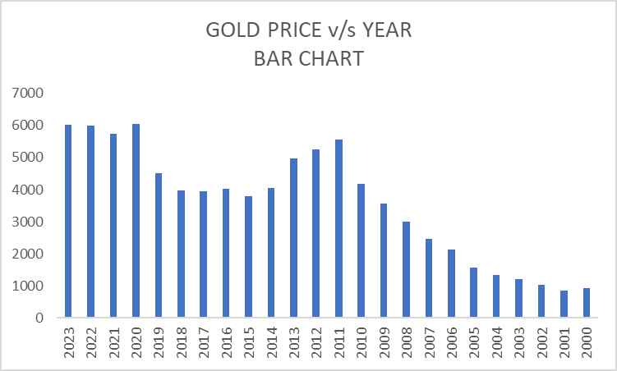

GRAPH 4.2

DESCRIPTIVE STATISTCS IN THE DATA OF GOLD PRICE’S ANNUAL CHANGE USING IBM SPSS 23:

TABLE 4.4:

|  |  |  |  |  |
| --- | --- | --- | --- | --- |
| **Descriptives** | | | | |
|  | | | Statistic | Std. Error |
| annualchange_g | Mean | | 9.2550 | 2.94698 |
| 95% Confidence Interval for Mean | Lower Bound | 3.1587 |  |
| Upper Bound | 15.3513 |  |
| 5% Trimmed Mean | | 9.9579 |  |
| Median | | 8.0950 |  |
| Variance | | 208.433 |  |
| Std. Deviation | | 14.43722 |  |
| Minimum | | -27.79 |  |
| Maximum | | 31.59 |  |
| Range | | 59.38 |  |
| Interquartile Range | | 23.60 |  |
| Skewness | | -.512 | .472 |
| Kurtosis | | .272 | .918 |

RESULT:

MEAN = 9.255%

MEDIAN = 8.095%

STANDARD DEVIATION = 14.4372

VARIANCE = 208.433

MINIMUM = -27.79%

MAXIMUM = 31.59

RANGE = 59.38

SKEWNESS = -0.512

KURTOSIS = 0.272

GRAPH 4.3:

GRAPH 4.4

DESCRIPTIVE STATISTCS IN THE DATA OF PLATINUM PRICE USING IBM SPSS 23:

TABLE 4.5:

|  |  |  |  |  |
| --- | --- | --- | --- | --- |
| **Descriptives** | | | | |
|  | | | Statistic | Std. Error |
| platinum_price | Mean | | 3679.0650651 | 254.86730916 |
| 95% Confidence Interval for Mean | Lower Bound | 3151.8318664 |  |
| Upper Bound | 4206.2982639 |  |
| 5% Trimmed Mean | | 3628.8285547 |  |
| Median | | 3414.7764160 |  |
| Variance | | 1558976.287 |  |
| Std. Deviation | | 1248.58971911 |  |
| Minimum | | 1779.62119 |  |
| Maximum | | 6664.05099 |  |
| Range | | 4884.42981 |  |
| Interquartile Range | | 1603.27157 |  |
| Skewness | | .491 | .472 |
| Kurtosis | | -.052 | .918 |

RESULT:

MEAN = 3679.0650

MEDIAN = 3414.7764

STANDARD DEVIATION = 1248.5897

VARIANCE = 1558976.287

MINIMUM = 1779.6211

MAXIMUM = 6664.0509

RANGE = 4884.42981

SKEWNESS = 0.491

KURTOSIS = -0.052

GRAPH 4.5:

GRAPH 4.6:

DESCRIPTIVE STATISTCS IN THE DATA OF PLATINUM PRICE’S ANNUAL CHANGE USING IBM SPSS 23:

TABLE 4.6:

|  |  |  |  |  |
| --- | --- | --- | --- | --- |
| **Descriptives** | | | | |
|  | | | Statistic | Std. Error |
| annualchange_p | Mean | | 5.9204 | 5.00756 |
| 95% Confidence Interval for Mean | Lower Bound | -4.4385 |  |
| Upper Bound | 16.2793 |  |
| 5% Trimmed Mean | | 5.4689 |  |
| Median | | 8.1700 |  |
| Variance | | 601.815 |  |
| Std. Deviation | | 24.53193 |  |
| Minimum | | -41.46 |  |
| Maximum | | 62.69 |  |
| Range | | 104.15 |  |
| Interquartile Range | | 34.09 |  |
| Skewness | | .254 | .472 |
| Kurtosis | | -.055 | .918 |

RESULT:

MEAN = 5.9204%

MEDIAN = 8.17%

STANDARD DEVIATION = 24.5319

VARIANCE = 601.815

MINIMUM = -41.46%

MAXIMUM = 62.69%

RANGE = 104.15

SKEWNESS = 0.254

KURTOSIS = -0.055

GRAPH 4.7:

GRAPH 4.8:

TIME SERIES

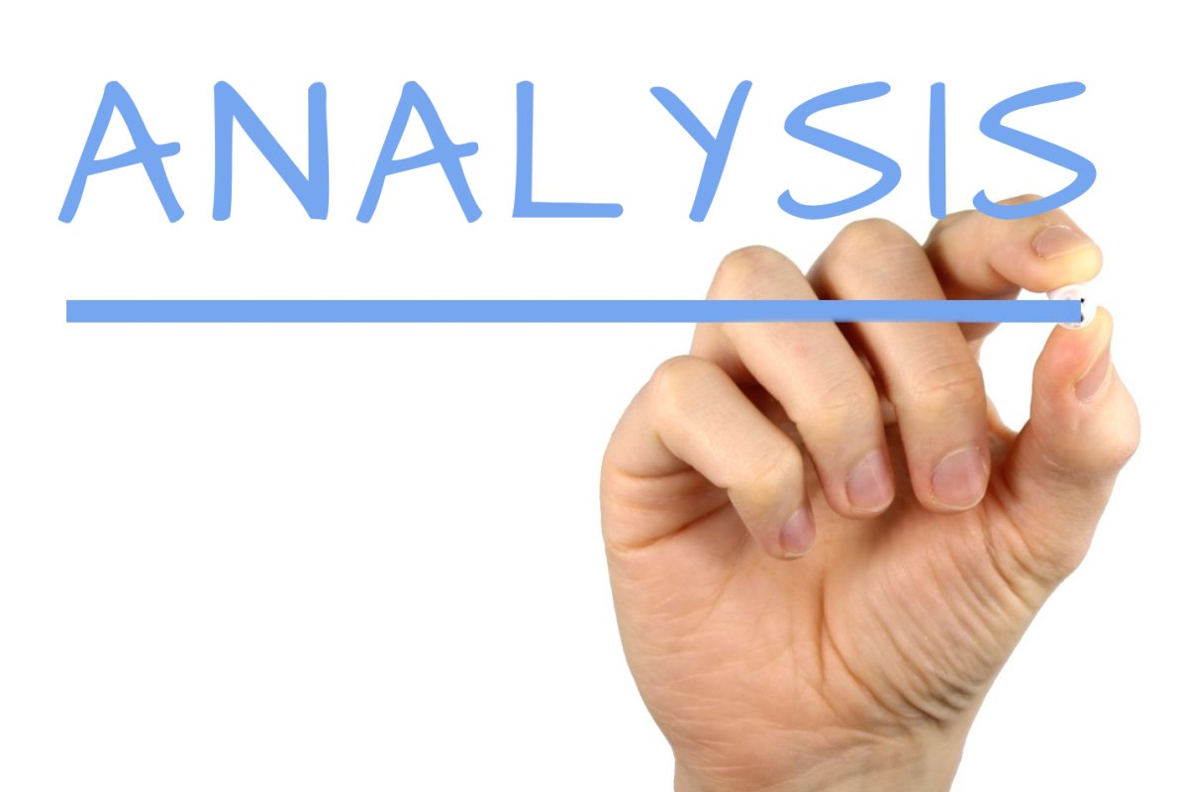

SEMI AVERAGE OF GOLD PRICE:

TABLE 5.1:

|  |  |  |  |
| --- | --- | --- | --- |
| YEAR | GOLD PRICE | SEMI TOTAL | SEMI AVERAGE |
| 2023 | 6019.4294 |  |  |
| 2022 | 5990.6095 |  |  |
| 2021 | 5729.96976 |  |  |
| 2020 | 6034.88014 |  |  |
| 2019 | 4522.64191 |  |  |
| 2018 | 3988.0226 |  |  |
| 2017 | 3961.48953 | 58329.88423 | 4860.823685 |
| 2016 | 4024.23071 |  |  |
| 2015 | 3805.51614 |  |  |
| 2014 | 4042.99442 |  |  |
| 2013 | 4962.12332 |  |  |
| 2012 | 5247.97681 |  |  |
| 2011 | 5560.21677 |  |  |
| 2010 | 4180.79046 |  |  |
| 2009 | 3571.70265 |  |  |
| 2008 | 3000.72864 |  |  |
| 2007 | 2467.86842 |  |  |
| 2006 | 2127.77607 |  |  |
| 2005 | 1575.85896 | 27852.97723 | 2321.081436 |
| 2004 | 1336.1818 |  |  |
| 2003 | 1223.30633 |  |  |
| 2002 | 1021.74297 |  |  |
| 2001 | 858.586596 |  |  |
| 2000 | 928.217573 |  |  |

3-YEAR MOVING AVERAGE OF GOLD PRICE:

TABLE 5.2:

|  |  |  |  |  |
| --- | --- | --- | --- | --- |
| **YEAR** | **GOLD PRICE** | **3 YEAR TOTAL** | **3 YEAR MOVING AVERAGE** | **TREND ELIMINATION** |
| 2023 | 6019.4294 | -- | -- | -- |
| 2022 | 5990.6095 | 17740.00866 | 5913.336218 | 77.273282 |
| 2021 | 5729.96976 | 17755.4594 | 5918.486467 | -188.516707 |
| 2020 | 6034.88014 | 16287.49181 | 5429.163937 | 605.716203 |
| 2019 | 4522.64191 | 14545.54465 | 4848.514883 | -325.872973 |
| 2018 | 3988.0226 | 12472.15404 | 4157.384679 | -169.362079 |
| 2017 | 3961.48953 | 11973.74284 | 3991.247611 | -29.758081 |
| 2016 | 4024.23071 | 11791.23638 | 3930.412125 | 93.818585 |
| 2015 | 3805.51614 | 11872.74127 | 3957.580422 | -152.064282 |
| 2014 | 4042.99442 | 12810.63388 | 4270.211294 | -227.216874 |
| 2013 | 4962.12332 | 14253.09455 | 4751.031515 | 211.091805 |
| 2012 | 5247.97681 | 15770.3169 | 5256.772297 | -8.795487 |
| 2011 | 5560.21677 | 14988.98404 | 4996.32801 | 563.88876 |
| 2010 | 4180.79046 | 13312.70988 | 4437.569959 | -256.779499 |
| 2009 | 3571.70265 | 10753.22175 | 3584.407249 | -12.704599 |
| 2008 | 3000.72864 | 9040.29971 | 3013.433236 | -12.704596 |
| 2007 | 2467.86842 | 7596.37313 | 2532.124376 | -64.255956 |
| 2006 | 2127.77607 | 6171.50345 | 2057.167816 | 70.608254 |
| 2005 | 1575.85896 | 5039.81683 | 1679.938944 | -104.079984 |
| 2004 | 1336.1818 | 4135.34709 | 1378.449029 | -42.267229 |
| 2003 | 1223.30633 | 3581.2311 | 1193.7437 | 29.56263 |
| 2002 | 1021.74297 | 3103.635896 | 1034.545297 | -12.802327 |
| 2001 | 858.586596 | 2808.547139 | 936.1823799 | -77.5957839 |
| 2000 | 928.217573 | -- | -- | -- |

GRAPH 5.1:

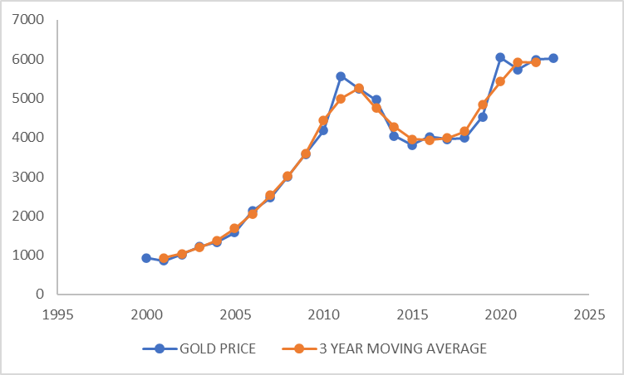

5-YEAR MOVING AVERAGE OF GOLD PRICE:

TABLE 5.3:

|  |  |  |  |  |
| --- | --- | --- | --- | --- |
| **YEAR** | **GOLD PRICE** | **5 YEAR TOTAL** | **5 YEAR MOVING AVERAGE** | **TREND ELIMINATION** |
| 2023 | 6019.4294 | -- | -- | -- |
| 2022 | 5990.6095 | -- | -- | -- |
| 2021 | 5729.96976 | 28297.53071 | 5659.506141 | 70.4636168 |
| 2020 | 6034.88014 | 26266.12391 | 5253.224782 | 781.6553614 |
| 2019 | 4522.64191 | 24237.00394 | 4847.400788 | -324.7588776 |
| 2018 | 3988.0226 | 22531.26489 | 4506.252977 | -518.23038 |
| 2017 | 3961.48953 | 20301.90088 | 4060.380177 | -98.8906466 |
| 2016 | 4024.23071 | 19822.25339 | 3964.450679 | 59.7800262 |
| 2015 | 3805.51614 | 20796.35412 | 4159.270823 | -353.7546824 |
| 2014 | 4042.99442 | 22082.84139 | 4416.568278 | -373.5738574 |
| 2013 | 4962.12332 | 23618.82745 | 4723.765491 | 238.3578294 |
| 2012 | 5247.97681 | 23994.10177 | 4798.820354 | 449.1564506 |
| 2011 | 5560.21677 | 23522.81 | 4704.562 | 855.6547658 |
| 2010 | 4180.79046 | 21561.41532 | 4312.283064 | -131.4926036 |
| 2009 | 3571.70265 | 18781.30694 | 3756.261387 | -184.558737 |
| 2008 | 3000.72864 | 15348.86624 | 3069.773248 | -69.0446108 |
| 2007 | 2467.86842 | 12743.93474 | 2548.786947 | -80.9185252 |
| 2006 | 2127.77607 | 10508.41389 | 2101.682778 | 26.093292 |
| 2005 | 1575.85896 | 8730.991578 | 1746.198316 | -170.3393586 |
| 2004 | 1336.1818 | 7284.866126 | 1456.973225 | -120.7914212 |
| 2003 | 1223.30633 | 6015.676652 | 1203.13533 | 20.17099454 |
| 2002 | 1021.74297 | 5368.035269 | 1073.607054 | -51.86408374 |
| 2001 | 858.586596 | -- | -- | -- |
| 2000 | 928.217573 | -- | -- | -- |

GRAPH 5.2:

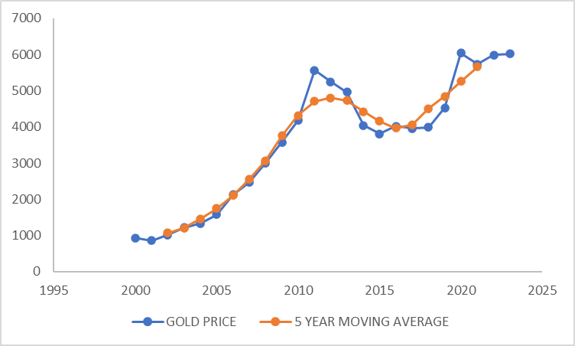

7-YEAR MOVING AVERAGE OF GOLD PRICE:

TABLE 5.4:

|  |  |  |  |  |
| --- | --- | --- | --- | --- |
| **YEAR** | **GOLD PRICE** | **7 YEAR TOTAL** | **7 YEAR MOVING AVERAGE** | **TREND ELIMINATION** |
| 2023 | 6019.4294 | -- | -- | -- |
| 2022 | 5990.6095 | -- | -- | -- |
| 2021 | 5729.96976 | -- | -- | -- |
| 2020 | 6034.88014 | 36247.04283 | 5178.148976 | 856.7311669 |
| 2019 | 4522.64191 | 34251.84414 | 4893.120592 | -370.4786819 |
| 2018 | 3988.0226 | 32066.75078 | 4580.964398 | -592.9418007 |
| 2017 | 3961.48953 | 30379.77545 | 4339.967921 | -378.478391 |
| 2016 | 4024.23071 | 29307.01862 | 4186.716946 | -162.4862413 |
| 2015 | 3805.51614 | 30032.35352 | 4290.336217 | -484.820076 |
| 2014 | 4042.99442 | 31604.54769 | 4514.935384 | -471.940963 |
| 2013 | 4962.12332 | 31823.84862 | 4546.264088 | 415.8592317 |
| 2012 | 5247.97681 | 31371.32056 | 4481.617223 | 766.3595817 |
| 2011 | 5560.21677 | 30566.53306 | 4366.64758 | 1193.569186 |
| 2010 | 4180.79046 | 28991.40706 | 4141.62958 | 39.16088 |
| 2009 | 3571.70265 | 26157.05981 | 3736.72283 | -165.02018 |
| 2008 | 3000.72864 | 22484.94196 | 3212.134566 | -211.405929 |
| 2007 | 2467.86842 | 18260.907 | 2608.701 | -140.832578 |
| 2006 | 2127.77607 | 15303.42287 | 2186.203266 | -58.42719643 |
| 2005 | 1575.85896 | 12753.46319 | 1821.923312 | -246.0643551 |
| 2004 | 1336.1818 | 10611.32114 | 1515.903021 | -179.7212166 |
| 2003 | 1223.30633 | 9071.670296 | 1295.952899 | -72.64657439 |
| 2002 | 1021.74297 | -- | -- | -- |
| 2001 | 858.586596 | -- | -- | -- |
| 2000 | 928.217573 | -- | -- | -- |

GRAPH 5.3:

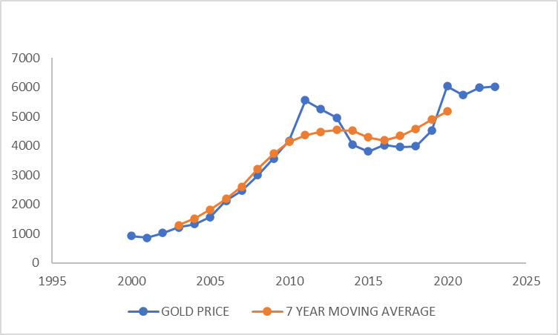

METHOD OF LEAST SQUARE FOR GOLD PRICE:

TABLE 5.5:

|  |  |  |  |  |  |  |
| --- | --- | --- | --- | --- | --- | --- |
| **YEAR** | **GOLD PRICE** | **X** | **XY** | **X²** | **TREND** | **FLUCTUATION** |
| 2023 | 6019.429395 | 11.5 | 69223.43804 | 132.25 | 6188.34415 | -168.914755 |
| 2022 | 5990.6095 | 10.5 | 62901.39975 | 110.25 | 5962.48405 | 28.12545 |
| 2021 | 5729.969758 | 9.5 | 54434.7127 | 90.25 | 5736.62395 | -6.654192 |
| 2020 | 6034.880143 | 8.5 | 51296.48122 | 72.25 | 5510.76385 | 524.116293 |
| 2019 | 4522.64191 | 7.5 | 33919.81433 | 56.25 | 5284.90375 | -762.26184 |
| 2018 | 3988.022597 | 6.5 | 25922.14688 | 42.25 | 5059.04365 | -1071.021053 |
| 2017 | 3961.48953 | 5.5 | 21788.19242 | 30.25 | 4833.18355 | -871.69402 |
| 2016 | 4024.230705 | 4.5 | 18109.03817 | 20.25 | 4607.32345 | -583.092745 |
| 2015 | 3805.516141 | 3.5 | 13319.30649 | 12.25 | 4381.46335 | -575.947209 |
| 2014 | 4042.994421 | 2.5 | 10107.48605 | 6.25 | 4155.60325 | -112.608829 |
| 2013 | 4962.12332 | 1.5 | 7443.18498 | 2.25 | 3929.74315 | 1032.38017 |
| 2012 | 5247.976805 | 0.5 | 2623.988403 | 0.25 | 3703.88305 | 1544.093755 |
| 2011 | 5560.216766 | -0.5 | -2780.108383 | 0.25 | 3478.02295 | 2082.193816 |
| 2010 | 4180.79046 | -1.5 | -6271.18569 | 2.25 | 3252.16285 | 928.62761 |
| 2009 | 3571.70265 | -2.5 | -8929.256625 | 6.25 | 3026.30275 | 545.3999 |
| 2008 | 3000.728637 | -3.5 | -10502.55023 | 12.25 | 2800.44265 | 200.285987 |
| 2007 | 2467.868422 | -4.5 | -11105.4079 | 20.25 | 2574.58255 | -106.714128 |
| 2006 | 2127.77607 | -5.5 | -11702.76839 | 30.25 | 2348.72245 | -220.94638 |
| 2005 | 1575.858957 | -6.5 | -10243.08322 | 42.25 | 2122.86235 | -547.003393 |
| 2004 | 1336.181804 | -7.5 | -10021.36353 | 56.25 | 1897.00225 | -560.820446 |
| 2003 | 1223.306325 | -8.5 | -10398.10376 | 72.25 | 1671.14215 | -447.835825 |
| 2002 | 1021.74297 | -9.5 | -9706.558215 | 90.25 | 1445.28205 | -423.53908 |
| 2001 | 858.5865963 | -10.5 | -9015.159261 | 110.25 | 1219.42195 | -360.8353537 |
| 2000 | 928.2175734 | -11.5 | -10674.50209 | 132.25 | 993.56185 | -65.3442766 |
|  | Ʃy= 86182.86 | Ʃx=0 | Ʃxy = 259739.1 | Ʃx² = 1150 |  |  |

GRAPH 5.4:

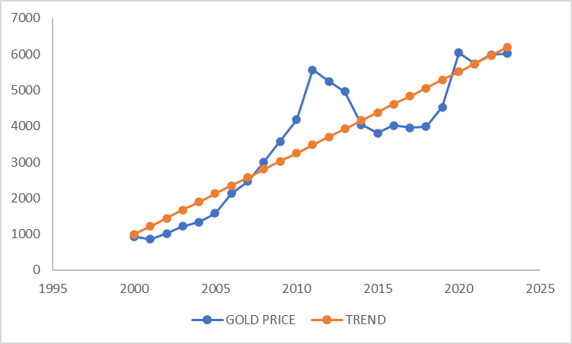

METHOD OF SIMPLE AVERAGE FOR GOLD PRICE

TABLE 5.6:

|  |  |  |  |  |
| --- | --- | --- | --- | --- |
| **Year** | **I QUARTER** | **II QUARTER** | **III QUARTER** | **IV QUARTER** |
| 2023 | 5666.99404 | 5348.12814 | 5310.336842 | 5867.853752 |
| 2022 | 5282.77763 | 5277.58829 | 4769.062274 | 5348.597232 |
| 2021 | 5274.04078 | 5707.10148 | 4919.611776 | 5361.145467 |
| 2020 | 5200.27592 | 4457.99505 | 4316.680809 | 5556.112203 |
| 2019 | 4085.03687 | 3773.85237 | 3723.571475 | 4465.17803 |
| 2018 | 3720.28783 | 3848.90723 | 3449.885087 | 3757.580711 |
| 2017 | 3695.24999 | 3406.78718 | 3406.787177 | 3801.118395 |
| 2016 | 3670.41739 | 3152.30428 | 3147.613351 | 3376.589322 |
| 2015 | 3397.58123 | 3472.02041 | 3077.249416 | 3108.32682 |
| 2014 | 3711.87347 | 3576.1004 | 3355.480141 | 3515.997868 |
| 2013 | 4132.44457 | 4929.87318 | 3496.940969 | 3522.594487 |
| 2012 | 4892.81484 | 4661.61068 | 4507.689574 | 4878.566147 |
| 2011 | 4612.23865 | 4120.68793 | 3858.289092 | 4616.167307 |
| 2010 | 3596.35935 | 3263.12748 | 3085.018767 | 4134.614128 |
| 2009 | 2854.6062 | 2549.95968 | 2383.578292 | 3236.741001 |
| 2008 | 2557.64108 | 2464.93659 | 2030.292702 | 2536.033484 |
| 2007 | 2041.8148 | 1878.57047 | 1783.432564 | 2452.476311 |
| 2006 | 1771.82252 | 1526.75079 | 1526.750794 | 1863.764723 |
| 2005 | 1304.63531 | 1251.30531 | 1206.448299 | 1504.029107 |
| 2004 | 1200.67259 | 1217.29607 | 1095.038736 | 1284.14181 |
| 2003 | 1066.68793 | 1003.27244 | 937.4528399 | 1223.306325 |
| 2002 | 909.102038 | 815.342095 | 814.4625455 | 1004.884944 |
| 2001 | 795.083145 | 799.803392 | 752.6009195 | 810.6511657 |
| 2000 | 818.830973 | 826.922826 | 773.4169168 | 799.3636178 |
| **TOTAL** | 76259.2891 | 73330.2438 | 67727.69136 | 78025.83436 |
| **AVERAGE** | 3177.47038 | 3055.42682 | 2821.98714 | 3251.076432 |
| **SI** | 103.282318 | 99.3153441 | 91.72748691 | 105.6748511 |

RATIO TO TREND METHOD FOR GOLD PRICE

TABLE 5.7:

|  |  |  |  |  |  |  |  |  |  |  |
| --- | --- | --- | --- | --- | --- | --- | --- | --- | --- | --- |
| **YEAR** | **YEARLY TOTAL** | **YEARLY AVERAGE** | **X** | **XY** | **X²** | **TREND** | **1st** | **2nd** | **3rd** | **4th** |
| 2023.00 | 22193.31 | 5548.33 | 11.50 | 63805.77 | 132.25 | 5416.12 | 104.63 | 96.84 | 95.27 | 104.32 |
| 2022.00 | 20678.03 | 5169.51 | 10.50 | 54279.82 | 110.25 | 5212.67 | 101.34 | 102.09 | 92.25 | 102.96 |
| 2021.00 | 21261.90 | 5315.47 | 9.50 | 50497.01 | 90.25 | 5009.23 | 105.29 | 107.37 | 92.55 | 100.86 |
| 2020.00 | 19531.06 | 4882.77 | 8.50 | 41503.51 | 72.25 | 4805.78 | 108.21 | 91.30 | 88.41 | 113.79 |
| 2019.00 | 16047.64 | 4011.91 | 7.50 | 30089.32 | 56.25 | 4602.33 | 88.76 | 94.07 | 92.81 | 111.30 |
| 2018.00 | 14776.66 | 3694.17 | 6.50 | 24012.07 | 42.25 | 4398.89 | 84.57 | 104.19 | 93.39 | 101.72 |
| 2017.00 | 14309.94 | 3577.49 | 5.50 | 19676.17 | 30.25 | 4195.44 | 88.08 | 95.23 | 95.23 | 106.25 |
| 2016.00 | 13346.92 | 3336.73 | 4.50 | 15015.29 | 20.25 | 3992.00 | 91.94 | 94.47 | 94.33 | 101.19 |
| 2015.00 | 13055.18 | 3263.79 | 3.50 | 11423.28 | 12.25 | 3788.55 | 89.68 | 106.38 | 94.28 | 95.24 |
| 2014.00 | 14159.45 | 3539.86 | 2.50 | 8849.66 | 6.25 | 3585.10 | 103.54 | 101.02 | 94.79 | 99.33 |
| 2013.00 | 16081.85 | 4020.46 | 1.50 | 6030.69 | 2.25 | 3381.66 | 122.20 | 122.62 | 86.98 | 87.62 |
| 2012.00 | 18940.68 | 4735.17 | 0.50 | 2367.59 | 0.25 | 3178.21 | 153.95 | 98.45 | 95.20 | 103.03 |
| 2011.00 | 17207.38 | 4301.85 | -0.50 | -2150.92 | 0.25 | 2974.77 | 155.05 | 95.79 | 89.69 | 107.31 |
| 2010.00 | 14079.12 | 3519.78 | -1.50 | -5279.67 | 2.25 | 2771.32 | 129.77 | 92.71 | 87.65 | 117.47 |
| 2009.00 | 11024.89 | 2756.22 | -2.50 | -6890.55 | 6.25 | 2567.88 | 111.17 | 92.52 | 86.48 | 117.43 |
| 2008.00 | 9588.90 | 2397.23 | -3.50 | -8390.29 | 12.25 | 2364.43 | 108.17 | 102.82 | 84.69 | 105.79 |
| 2007.00 | 8156.29 | 2039.07 | -4.50 | -9175.83 | 20.25 | 2160.98 | 94.49 | 92.13 | 87.46 | 120.27 |
| 2006.00 | 6689.09 | 1672.27 | -5.50 | -9197.50 | 30.25 | 1957.54 | 90.51 | 91.30 | 91.30 | 111.45 |
| 2005.00 | 5266.42 | 1316.60 | -6.50 | -8557.93 | 42.25 | 1754.09 | 74.38 | 95.04 | 91.63 | 114.24 |
| 2004.00 | 4797.15 | 1199.29 | -7.50 | -8994.65 | 56.25 | 1550.65 | 77.43 | 101.50 | 91.31 | 107.08 |
| 2003.00 | 4230.72 | 1057.68 | -8.50 | -8990.28 | 72.25 | 1347.20 | 79.18 | 94.86 | 88.63 | 115.66 |
| 2002.00 | 3543.79 | 885.95 | -9.50 | -8416.51 | 90.25 | 1143.75 | 79.48 | 92.03 | 91.93 | 113.42 |
| 2001.00 | 3158.14 | 789.53 | -10.50 | -8290.11 | 110.25 | 940.31 | 84.56 | 101.30 | 95.32 | 102.67 |
| 2000.00 | 3218.53 | 804.63 | -11.50 | -9253.29 | 132.25 | 736.86 | 111.12 | 102.77 | 96.12 | 99.35 |
| **TOTAL** |  | ƩY = 73835.76 | ƩX =0 | ƩXY = 233962.7 | ƩX² = 1150 |  | 2437.49 | 2368.78 | 2197.72 | 2559.74 |
| **AVERAGE** |  |  |  |  |  |  | 101.56 | 98.70 | 91.57 | 106.66 |
| **SI** |  |  |  |  |  |  | 101.95 | 99.72 | 92.39 | 100.00 |

SEMI AVERAGE OF PLATINUM PRICE

TABLE 5.8:

|  |  |  |  |
| --- | --- | --- | --- |
| **YEAR** | **PLATINUM PRICE** | **SEMI TOTAL** | **SEMI AVERAGE** |
| 2023 | 3295.377614 |  |  |
| 2022 | 3380.987068 |  |  |
| 2021 | 3791.150171 |  |  |
| 2020 | 3161.803411 |  |  |
| 2019 | 2885.507694 |  |  |
| 2018 | 3025.94238 |  |  |
| 2017 | 3015.622336 | 44364.07976 | 3697.006647 |
| 2016 | 3448.565764 |  |  |
| 2015 | 3767.402343 |  |  |
| 2014 | 4432.927893 |  |  |
| 2013 | 5089.657952 |  |  |
| 2012 | 5069.135137 |  |  |
| 2011 | 5532.364375 |  |  |
| 2010 | 5236.249482 |  |  |
| 2009 | 4380.154942 |  |  |
| 2008 | 6664.050993 |  |  |
| 2007 | 4526.746473 |  |  |
| 2006 | 3972.630486 |  |  |
| 2005 | 2943.55794 | 43933.4818 | 3661.123483 |
| 2004 | 2744.193458 |  |  |
| 2003 | 2462.737719 |  |  |
| 2002 | 1779.621185 |  |  |
| 2001 | 1867.576103 |  |  |
| 2000 | 1823.598644 |  |  |

3 YEAR MOVING AVERAGE OF PLATINUM PRICE

TABLE 5.9:

|  |  |  |  |  |
| --- | --- | --- | --- | --- |
| **YEAR** | **PLATINUM PRICE** | **3 YEAR TOTAL** | **3 YEAR MOVING AVERAGE** | **TREND ELIMINATION** |
| 2023 | 3295.377614 | -- | -- | -- |
| 2022 | 3380.987068 | 10467.51485 | 3489.171618 | -108.1845497 |
| 2021 | 3791.150171 | 10333.94065 | 3444.646883 | 346.5032877 |
| 2020 | 3161.803411 | 9838.461276 | 3279.487092 | -117.683681 |
| 2019 | 2885.507694 | 9073.253485 | 3024.417828 | -138.9101343 |
| 2018 | 3025.94238 | 8927.07241 | 2975.690803 | 50.25157667 |
| 2017 | 3015.622336 | 9490.13048 | 3163.376827 | -147.7544907 |
| 2016 | 3448.565764 | 10231.59044 | 3410.530148 | 38.03561633 |
| 2015 | 3767.402343 | 11648.896 | 3882.965333 | -115.5629903 |
| 2014 | 4432.927893 | 13289.98819 | 4429.996063 | 2.931830333 |
| 2013 | 5089.657952 | 14591.72098 | 4863.906994 | 225.750958 |
| 2012 | 5069.135137 | 15691.15746 | 5230.385821 | -161.2506843 |
| 2011 | 5532.364375 | 15837.74899 | 5279.249665 | 253.1147103 |
| 2010 | 5236.249482 | 15148.7688 | 5049.5896 | 186.6598823 |
| 2009 | 4380.154942 | 16280.45542 | 5426.818472 | -1046.66353 |
| 2008 | 6664.050993 | 15570.95241 | 5190.317469 | 1473.733524 |
| 2007 | 4526.746473 | 15163.42795 | 5054.475984 | -527.729511 |
| 2006 | 3972.630486 | 11442.9349 | 3814.311633 | 158.318853 |
| 2005 | 2943.55794 | 9660.381884 | 3220.127295 | -276.5693547 |
| 2004 | 2744.193458 | 8150.489117 | 2716.829706 | 27.36375233 |
| 2003 | 2462.737719 | 6986.552362 | 2328.850787 | 133.8869317 |
| 2002 | 1779.621185 | 6109.935007 | 2036.645002 | -257.0238173 |
| 2001 | 1867.576103 | 5470.795932 | 1823.598644 | 43.977459 |
| 2000 | 1823.598644 | -- | -- | -- |

GRAPH 5.5:

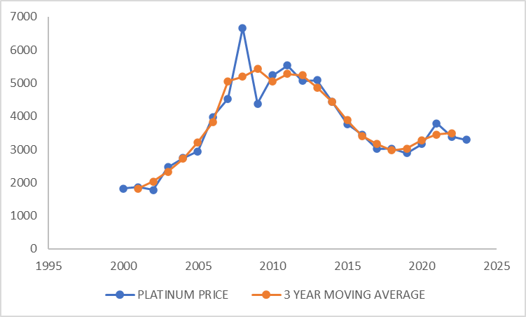

5 YEAR MOVING AVERAGE OF PLATINUM PRICE:

TABLE 5.10:

|  |  |  |  |  |
| --- | --- | --- | --- | --- |
| **YEAR** | **PLATINUM PRICE** | **5 YEAR TOTAL** | **5 YEAR MOVING AVERAGE** | **TREND ELIMINATION** |
| 2023 | 3295.377614 | -- | -- | -- |
| 2022 | 3380.987068 | -- | -- | -- |
| 2021 | 3791.150171 | 16514.82596 | 3302.965192 | 488.1849794 |
| 2020 | 3161.803411 | 16245.39072 | 3249.078145 | -87.2747338 |
| 2019 | 2885.507694 | 15880.02599 | 3176.005198 | -290.4975044 |
| 2018 | 3025.94238 | 15537.44159 | 3107.488317 | -81.545937 |
| 2017 | 3015.622336 | 16143.04052 | 3228.608103 | -212.9857674 |
| 2016 | 3448.565764 | 17690.46072 | 3538.092143 | -89.5263792 |
| 2015 | 3767.402343 | 19754.17629 | 3950.835258 | -183.4329146 |
| 2014 | 4432.927893 | 21807.68909 | 4361.537818 | 71.3900752 |
| 2013 | 5089.657952 | 23891.4877 | 4778.29754 | 311.360412 |
| 2012 | 5069.135137 | 25360.33484 | 5072.066968 | -2.9318308 |
| 2011 | 5532.364375 | 25307.56189 | 5061.512378 | 470.8519974 |
| 2010 | 5236.249482 | 26881.95493 | 5376.390986 | -140.1415038 |
| 2009 | 4380.154942 | 26339.56627 | 5267.913253 | -887.758311 |
| 2008 | 6664.050993 | 24779.83238 | 4955.966475 | 1708.084518 |
| 2007 | 4526.746473 | 22487.14083 | 4497.428167 | 29.3183062 |
| 2006 | 3972.630486 | 20851.17935 | 4170.23587 | -197.605384 |
| 2005 | 2943.55794 | 16649.86608 | 3329.973215 | -386.4152752 |
| 2004 | 2744.193458 | 13902.74079 | 2780.548158 | -36.3546996 |
| 2003 | 2462.737719 | 11797.68641 | 2359.537281 | 103.200438 |
| 2002 | 1779.621185 | 10677.72711 | 2135.545422 | -355.9242368 |
| 2001 | 1867.576103 | -- | -- | -- |
| 2000 | 1823.598644 | -- | -- | -- |

GRAPH 5.6:

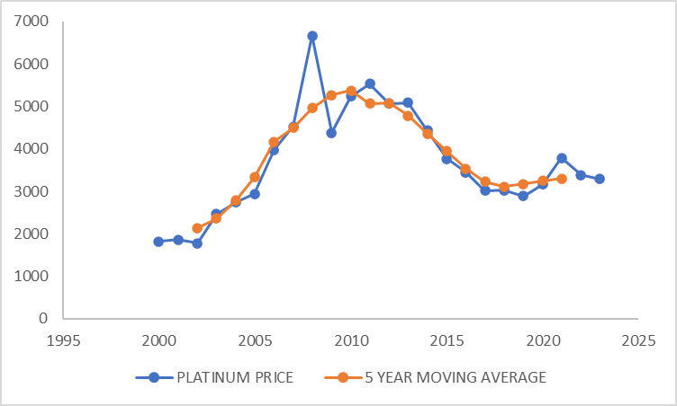

7 YEAR MOVING AVERAGE OF PLATINUM PRICES

TABLE 5.11:

|  |  |  |  |  |
| --- | --- | --- | --- | --- |
| **YEAR** | **PLATINUM PRICE** | **7 YEAR TOTAL** | **7 YEAR MOVING AVERAGE** | **TREND ELIMINATION** |
| 2023 | 3295.377614 | -- | -- | -- |
| 2022 | 3380.987068 | -- | -- | -- |
| 2021 | 3791.150171 | -- | -- | -- |
| 2020 | 3161.803411 | 22556.39067 | 3222.341525 | -60.53811386 |
| 2019 | 2885.507694 | 22709.57882 | 3244.225546 | -358.7178523 |
| 2018 | 3025.94238 | 23095.9941 | 3299.427728 | -273.4853484 |
| 2017 | 3015.622336 | 23737.77182 | 3391.11026 | -375.4879241 |
| 2016 | 3448.565764 | 25665.62636 | 3666.518052 | -217.9522877 |
| 2015 | 3767.402343 | 27849.25381 | 3978.464829 | -211.0624863 |
| 2014 | 4432.927893 | 30355.6758 | 4336.525114 | 96.40277871 |
| 2013 | 5089.657952 | 32576.30295 | 4653.757564 | 435.9003883 |
| 2012 | 5069.135137 | 33507.89212 | 4786.841732 | 282.293405 |
| 2011 | 5532.364375 | 36404.54077 | 5200.648682 | 331.715693 |
| 2010 | 5236.249482 | 36498.35935 | 5214.051336 | 22.19814571 |
| 2009 | 4380.154942 | 35381.33189 | 5054.475984 | -674.321042 |
| 2008 | 6664.050993 | 33255.75469 | 4750.822099 | 1913.228894 |
| 2007 | 4526.746473 | 30467.58377 | 4352.511968 | 174.2345053 |
| 2006 | 3972.630486 | 27694.07201 | 3956.296002 | 16.33448443 |
| 2005 | 2943.55794 | 25093.53825 | 3584.791179 | -641.2332391 |
| 2004 | 2744.193458 | 20297.06336 | 2899.580481 | -155.3870226 |
| 2003 | 2462.737719 | 17593.91554 | 2513.416505 | -50.678786 |
| 2002 | 1779.621185 | -- | -- | -- |
| 2001 | 1867.576103 | -- | -- | -- |
| 2000 | 1823.598644 | -- | -- | -- |

GRAPH 5.7:

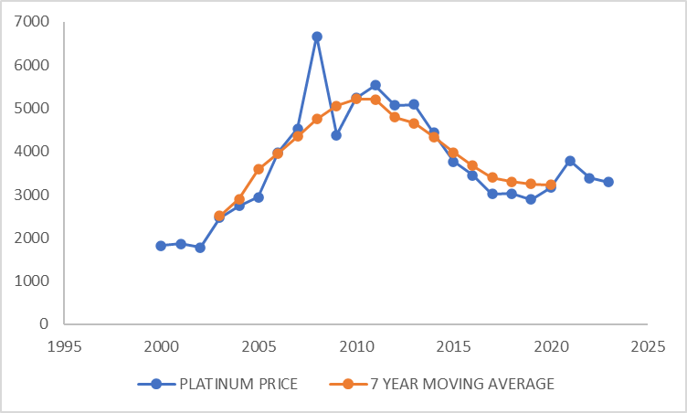

METHOD OF LEAST SQUARE FOR PLATINUM PRICES

TABLE 5.12:

|  |  |  |  |  |  |
| --- | --- | --- | --- | --- | --- |
| **YEAR** | **PLATINUM PRICE** | **X** | **XY** | **X²** | **TREND** |
| 2023 | 3295.377614 | 11.5 | 37896.84256 | 132.25 | 4067.9651 |
| 2022 | 3380.987068 | 10.5 | 35500.36421 | 110.25 | 4034.1477 |
| 2021 | 3791.150171 | 9.5 | 36015.92662 | 90.25 | 4000.3303 |
| 2020 | 3161.803411 | 8.5 | 26875.32899 | 72.25 | 3966.5129 |
| 2019 | 2885.507694 | 7.5 | 21641.30771 | 56.25 | 3932.6955 |
| 2018 | 3025.94238 | 6.5 | 19668.62547 | 42.25 | 3898.8781 |
| 2017 | 3015.622336 | 5.5 | 16585.92285 | 30.25 | 3865.0607 |
| 2016 | 3448.565764 | 4.5 | 15518.54594 | 20.25 | 3831.2433 |
| 2015 | 3767.402343 | 3.5 | 13185.9082 | 12.25 | 3797.4259 |
| 2014 | 4432.927893 | 2.5 | 11082.31973 | 6.25 | 3763.6085 |
| 2013 | 5089.657952 | 1.5 | 7634.486928 | 2.25 | 3729.7911 |
| 2012 | 5069.135137 | 0.5 | 2534.567569 | 0.25 | 3695.9737 |
| 2011 | 5532.364375 | -0.5 | -2766.182188 | 0.25 | 3662.1563 |
| 2010 | 5236.249482 | -1.5 | -7854.374223 | 2.25 | 3628.3389 |
| 2009 | 4380.154942 | -2.5 | -10950.38736 | 6.25 | 3594.5215 |
| 2008 | 6664.050993 | -3.5 | -23324.17848 | 12.25 | 3560.7041 |
| 2007 | 4526.746473 | -4.5 | -20370.35913 | 20.25 | 3526.8867 |
| 2006 | 3972.630486 | -5.5 | -21849.46767 | 30.25 | 3493.0693 |
| 2005 | 2943.55794 | -6.5 | -19133.12661 | 42.25 | 3459.2519 |
| 2004 | 2744.193458 | -7.5 | -20581.45094 | 56.25 | 3425.4345 |
| 2003 | 2462.737719 | -8.5 | -20933.27061 | 72.25 | 3391.6171 |
| 2002 | 1779.621185 | -9.5 | -16906.40126 | 90.25 | 3357.7997 |
| 2001 | 1867.576103 | -10.5 | -19609.54908 | 110.25 | 3323.9823 |
| 2000 | 1823.598644 | -11.5 | -20971.38441 | 132.25 | 3290.1649 |
|  | ƩY = 88297.56 | ƩX =0 | ƩXY = 38890.01 | ƩX² = 1150 |  |

GRAPH 5.8:

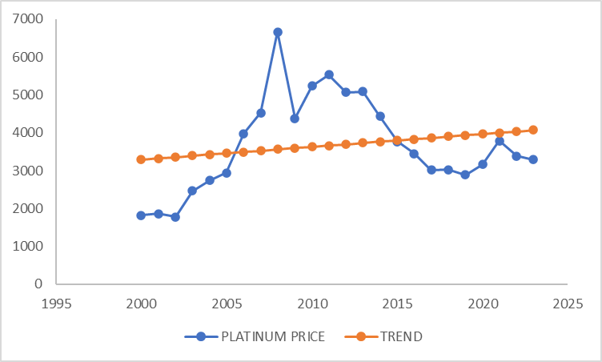

METHOD OF SIMPLE AVERAGE OF PLATINUM PRICE

TABLE 5.13:

|  |  |  |  |  |
| --- | --- | --- | --- | --- |
| **YEAR** | **I QUARTER** | **II QUARTER** | **III QUARTER** | **IV QUARTER** |
| 2023 | 2835.37339 | 3134.12693 | 2471.53321 | 2729.534305 |
| 2022 | 2808.869641 | 2796.966409 | 2430.487582 | 3134.12693 |
| 2021 | 3191.326945 | 3141.456506 | 2621.642938 | 2831.679283 |
| 2020 | 2619.268155 | 2887.853158 | 1749.716512 | 3161.803411 |
| 2019 | 2544.946249 | 2357.191816 | 2306.177964 | 2862.991234 |
| 2018 | 2586.402334 | 2778.789059 | 2263.080053 | 2344.467671 |
| 2017 | 2786.675683 | 2745.688691 | 2566.524522 | 2748.532567 |
| 2016 | 2899.287297 | 2612.554263 | 2399.556769 | 2647.73623 |
| 2015 | 3080.210565 | 3497.673926 | 2437.230792 | 2613.873587 |
| 2014 | 4056.539479 | 4069.380897 | 3453.696467 | 3535.787724 |
| 2013 | 4352.976872 | 4591.246747 | 3861.220923 | 3978.494148 |
| 2012 | 4546.946786 | 4122.153848 | 4075.244558 | 4476.905353 |
| 2011 | 5039.904786 | 5145.362733 | 3969.698656 | 3969.698656 |
| 2010 | 4724.674358 | 4397.745926 | 4324.45016 | 5145.362733 |
| 2009 | 3535.17204 | 2714.875152 | 2474.465041 | 4283.404532 |
| 2008 | 4606.023173 | 4517.950981 | 2236.986761 | 2632.783894 |
| 2007 | 3829.615789 | 3330.559581 | 3283.650291 | 4497.428167 |
| 2006 | 3349.323297 | 2879.057666 | 2879.057666 | 3277.78663 |
| 2005 | 2629.617517 | 2524.306161 | 2474.465041 | 2829.216546 |
| 2004 | 2479.830291 | 2390.907868 | 2248.714083 | 2524.306161 |
| 2003 | 2028.914742 | 1782.553015 | 1767.893862 | 2383.578292 |
| 2002 | 1583.159215 | 1410.210527 | 1328.11927 | 1753.234709 |
| 2001 | 1548.768842 | 1782.553015 | 1216.709706 | 1407.278696 |
| 2000 | 1596.147225 | 1298.800963 | 1213.777876 | 1814.803152 |
| **TOTAL** | 75259.97467 | 72909.96584 | 62054.1007 | 73584.81461 |
| **AVERAGE** | 3135.832278 | 3037.915243 | 2585.587529 | 3066.033942 |
| **SI** | 106.0713549 | 102.7592541 | 87.4590055 | 103.7103855 |

RATIO TO TREND METHOD FOR PLATINUM PRICE

TABLE 5.14:

|  |  |  |  |  |  |  |  |  |  |  |
| --- | --- | --- | --- | --- | --- | --- | --- | --- | --- | --- |
| **Year** | **YEARLY TOTAL** | **YEARLY AVERAGE** | **X** | **XY** | **X²** | **TREND** | **1st** | **2nd** | **3rd** | **4th** |
| 2023 | 11170.57 | 2792.64 | 11.50 | 32115.38 | 132.25 | 3346.18 | 101.99 | 112.40 | 88.37 | 97.30 |
| 2022 | 11170.45 | 2792.61 | 10.50 | 29322.43 | 110.25 | 3312.29 | 100.89 | 100.31 | 87.03 | 112.06 |
| 2021 | 11786.11 | 2946.53 | 9.50 | 27992.00 | 90.25 | 3278.39 | 108.46 | 106.77 | 88.97 | 96.10 |
| 2020 | 10418.64 | 2604.66 | 8.50 | 22139.61 | 72.25 | 3244.49 | 100.72 | 111.05 | 67.18 | 121.39 |
| 2019 | 10071.31 | 2517.83 | 7.50 | 18883.70 | 56.25 | 3210.59 | 101.25 | 93.78 | 91.59 | 113.71 |
| 2018 | 9972.74 | 2493.18 | 6.50 | 16205.70 | 42.25 | 3176.69 | 103.92 | 111.65 | 90.77 | 94.04 |
| 2017 | 10847.42 | 2711.86 | 5.50 | 14915.20 | 30.25 | 3142.79 | 102.92 | 101.41 | 94.64 | 101.35 |
| 2016 | 10559.13 | 2639.78 | 4.50 | 11879.03 | 20.25 | 3108.89 | 110.01 | 99.13 | 90.90 | 100.30 |
| 2015 | 11628.99 | 2907.25 | 3.50 | 10175.37 | 12.25 | 3074.99 | 106.10 | 120.48 | 83.83 | 89.91 |
| 2014 | 15115.40 | 3778.85 | 2.50 | 9447.13 | 6.25 | 3041.09 | 107.47 | 107.81 | 91.40 | 93.57 |
| 2013 | 16783.94 | 4195.98 | 1.50 | 6293.98 | 2.25 | 3007.19 | 103.85 | 109.53 | 92.02 | 94.82 |
| 2012 | 17221.25 | 4305.31 | 0.50 | 2152.66 | 0.25 | 2973.29 | 105.72 | 95.84 | 94.66 | 103.99 |
| 2011 | 18124.66 | 4531.17 | -0.50 | -2265.58 | 0.25 | 2939.39 | 111.33 | 113.66 | 87.61 | 87.61 |
| 2010 | 18592.23 | 4648.06 | -1.50 | -6972.09 | 2.25 | 2905.49 | 101.74 | 94.70 | 93.04 | 110.70 |
| 2009 | 13007.92 | 3251.98 | -2.50 | -8129.95 | 6.25 | 2871.59 | 108.85 | 83.59 | 76.09 | 131.72 |
| 2008 | 13993.74 | 3498.44 | -3.50 | -12244.53 | 12.25 | 2837.69 | 131.82 | 129.30 | 63.94 | 75.26 |
| 2007 | 14941.25 | 3735.31 | -4.50 | -16808.91 | 20.25 | 2803.79 | 102.64 | 89.27 | 87.91 | 120.40 |
| 2006 | 12385.23 | 3096.31 | -5.50 | -17029.68 | 30.25 | 2769.90 | 108.32 | 93.11 | 92.98 | 105.86 |
| 2005 | 10457.61 | 2614.40 | -6.50 | -16993.61 | 42.25 | 2736.00 | 100.75 | 96.71 | 94.65 | 108.22 |
| 2004 | 9643.76 | 2410.94 | -7.50 | -18082.05 | 56.25 | 2702.10 | 103.04 | 99.34 | 93.27 | 104.70 |
| 2003 | 7962.94 | 1990.73 | -8.50 | -16921.25 | 72.25 | 2668.20 | 102.14 | 89.73 | 88.81 | 119.73 |
| 2002 | 6074.72 | 1518.68 | -9.50 | -14427.47 | 90.25 | 2634.30 | 104.54 | 93.12 | 87.45 | 115.44 |
| 2001 | 5955.31 | 1488.83 | -10.50 | -15632.69 | 110.25 | 2600.40 | 104.32 | 120.07 | 81.72 | 94.52 |
| 2000 | 5923.53 | 1480.88 | -11.50 | -17030.15 | 132.25 | 2566.50 | 108.09 | 87.96 | 81.96 | 122.55 |
| **TOTAL** |  | ƩY = 70952.21 | ƩX =0 | ƩXY = 38984.24 | ƩX² = 1150 |  | 2540.87 | 2460.71 | 2090.80 | 2515.24 |
| **AVERAGE** |  |  |  |  |  |  | 105.87 | 102.53 | 87.12 | 104.80 |
| **SI** |  |  |  |  |  |  | 105.79 | 102.45 | 87.05 | 104.72 |

TESTING OF STATISTICAL



CORRELATION ANALYSIS IN THE PRICE OF GOLD AND PRICE OF PLATINUM :

HYPOTHESIS:

H0: The correlation coefficient is significant in the gold price and platinum price.

H1: The correlation coefficient is significant in the gold price and platinum price.

OUTPUT:

TABLE 6.1:

|  |  |  |  |
| --- | --- | --- | --- |
| **Correlations** | | | |
|  | | gold price | platinum price |
| gold price | Pearson Correlation | 1 | .456* |
| Sig. (2-tailed) |  | .025 |
| N | 24 | 24 |
| platinum price | Pearson Correlation | .456* | 1 |
| Sig. (2-tailed) | .025 |  |
| N | 24 | 24 |
| *. Correlation is significant at the 0.05 level (2-tailed). | | | |

INFERENCE:

CORRELATION COEFFICIENT = 0.456

The price of gold and price of platinum are positively low correlated (or related).

The calculated p-value (0.025) is greater than the level of significance value (0.05).

p-value < level of significance

Hence, we reject null hypothesis, the correlation coefficient is significant in the gold price and platinum price.

REGRESSION ANALYSIS IN THE PRICE OF GOLD AND YEAR:

HYPOTHESIS:

H0: The regression coefficient is not significant.

H1: The regression coefficient is significant.

OUTPUT:

TABLE 6.2:

|  |  |  |  |  |
| --- | --- | --- | --- | --- |
| **Model Summary** | | | | |
| Model | R | R Square | Adjusted R Square | Std. Error of the Estimate |
| 1 | .901a | .811 | .803 | 787.69745436 |
| a. Predictors: (Constant), year | | | | |

TABLE 6.3:

|  |  |  |  |  |  |  |
| --- | --- | --- | --- | --- | --- | --- |
| **Coefficientsa** | | | | | | |
| Model | | Unstandardized Coefficients | | Standardized Coefficients | t | Sig. |
| B | Std. Error | Beta |
| 1 | (Constant) | -450726.686 | 46723.259 |  | -9.647 | .000 |
| Year | 225.860 | 23.228 | .901 | 9.724 | .000 |
| a. Dependent Variable: gold_price | | | | | | |

INFERENCE:

The calculated p-value (0.000) is less than the level of significance value (0.05).

p-value < level of significance

Hence, we reject the null hypothesis and conclude that the regression coefficient is significant and the R2 value says that 81.1% of the variation is influenced by the independent variable.

THE REGRESSION EQUATION:

GOLD PRICE = 225.860 (YEAR) – 450726.686

REGRESSION ANALYSIS IN THE ANNUAL CHANGE OF PRICE OF GOLD AND YEAR:

HYPOTHESIS:

H0: The regression coefficient is not significant.

H1: The regression coefficient is significant

OUTPUT:

TABLE 6.4:

|  |  |  |  |  |
| --- | --- | --- | --- | --- |
| **Model Summary** | | | | |
| Model | R | R Square | Adjusted R Square | Std. Error of the Estimate |
| 1 | .87a | .83 | .81 | 14.44298 |
| a. Predictors: (Constant), year | | | | |

TABLE 6.5:

|  |  |  |  |  |  |  |
| --- | --- | --- | --- | --- | --- | --- |
| **Coefficientsa** | | | | | | |
| Model | | Unstandardized Coefficients | | Standardized Coefficients | t | Sig. |
| B | Std. Error | Beta |
| 1 | (Constant) | 858.056 | 856.703 |  | 1.002 | .000 |
| Year | -.422 | .426 | -.207 | -.991 | .007 |
| a. Dependent Variable: annualchange_g | | | | | | |

INFERENCE:

The calculated p-value (0.007) is less than the level of significance value (0.05).

p-value < level of significance

Hence, we reject the null hypothesis and conclude that the regression coefficient is significant and the R2 value says that 83% of the variation is influenced by the independent variable.

THE REGRESSION EQUATION:

ANNUAL CHANGE IN GOLD PRICE(%) = 858.056 -0.422 (YEAR)

REGRESSION ANALYSIS IN THE PRICE OF PLATINUM AND YEAR:

HYPOTHESIS:

H0: The regression coefficient is not significant.

H1: The regression coefficient is significant

OUTPUT:

TABLE 6.6:

|  |  |  |  |  |
| --- | --- | --- | --- | --- |
| **Model Summary** | | | | |
| Model | R | R Square | Adjusted R Square | Std. Error of the Estimate |
| 1 | .92a | .97 | .92 | 1253.01990193 |
| a. Predictors: (Constant), year | | | | |

TABLE 6.7:

|  |  |  |  |  |  |  |
| --- | --- | --- | --- | --- | --- | --- |
| **Coefficientsa** | | | | | | |
| Model | | Unstandardized Coefficients | | Standardized Coefficients | T | Sig. |
| B | Std. Error | Beta |
| 1 | (Constant) | -64344.643 | 74324.442 |  | -.866 | .000 |
| Year | 33.817 | 36.950 | .192 | .915 | .009 |
| a. Dependent Variable: platinum_price | | | | | | |

INFERENCE:

The calculated p-value (0.009) is less than the level of significance value (0.05).

p-value < level of significance

Hence, we reject the null hypothesis and conclude that the regression coefficient is significant and the R2 value says that 92% of the variation is influenced by the independent variable.

THE REGRESSION EQUATION:

PLATINUM PRICE = 33.817(YEAR) – 64344.643

REGRESSION ANALYSIS IN THE ANNUAL CHANGE OF PRICE OF PLATINUM AND YEAR:

HYPOTHESIS:

H0: The regression coefficient is not significant.

H1: The regression coefficient is significant

OUTPUT:

TABLE 4.14:

|  |  |  |  |  |
| --- | --- | --- | --- | --- |
| **Model Summary** | | | | |
| Model | R | R Square | Adjusted R Square | Std. Error of the Estimate |
| 1 | .93a | .98 | .97 | 23.82684 |
| a. Predictors: (Constant), year | | | | |

TABLE 4.15:

|  |  |  |  |  |  |  |
| --- | --- | --- | --- | --- | --- | --- |
| **Coefficientsa** | | | | | | |
| Model | | Unstandardized Coefficients | | Standardized Coefficients | T | Sig. |
| B | Std. Error | Beta |
| 1 | (Constant) | 2186.902 | 1413.319 |  | 1.547 | .006 |
| Year | -1.084 | .703 | -.313 | -1.543 | .037 |
| a. Dependent Variable: annualchange_p | | | | | | |

INFERENCE:

The calculated p-value (0.009) is less than the level of significance value (0.05).

p-value < level of significance

Hence, we reject the null hypothesis and conclude that the regression coefficient is significant and the R2 value says that 97% of the variation is influenced by the independent variable.

THE REGRESSION EQUATION:

ANNUAL CHANGE IN PLATINUM PRICE(%) = 2186.902 -1.084 (YEAR)

F-TEST:

HYPOTHESIS:

H0: There is no significant difference between the variance of gold price and platinum price.

H1: There is a significant difference between the variance of gold price and platinum price.

OUTPUT:

TABLE 6.2:

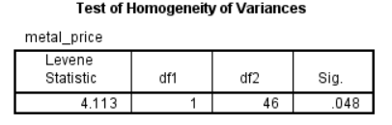

INFERENCE:

The calculated p-value (0.048) is less than the level of significance value (0.05).

p-value < level of significance

Hence, we accept the null hypothesis and conclude that there is no significant difference in variation of the price of gold and platinum.

CHAPTER-V

* GRAPHIC METHOD:
  1. The estimated value of gold price for 2024 to 2030

|  |  |  |  |  |  |  |  |
| --- | --- | --- | --- | --- | --- | --- | --- |
| **YEAR** | 2024 | 2025 | 2026 | 2027 | 2028 | 2029 | 2030 |
| **GOLD PRICE** | 6413.64 | 6639.5 | 6865.36 | 7091.22 | 7317.08 | 7542.94 | 7768.8 |

* 1. The estimated value of gold price for 2024 to 2030

|  |  |  |  |  |  |  |  |
| --- | --- | --- | --- | --- | --- | --- | --- |
| **YEAR** | 2024 | 2025 | 2026 | 2027 | 2028 | 2029 | 2030 |
| **PLATINUM PRICE** | 4100.608 | 4134.425 | 4168.242 | 4202.059 | 4235.876 | 4269.693 | 4303.51 |

* SEMI AVERAGE METHOD:

1. a) calculated average gold price for the first part is **4860.823685**

b) calculated average gold price for the second part is **2321.081436**

1. a) calculated average platinum price for the first part is **3697.006647**

b) calculated average platinum price for the second part is **3661.123483**

* MOVING AVERAGE METHOD:
  1. Gold prices are calculated using moving average method.

(3,5- and 7-year moving average) in TABLE 5.2 to TABLE 5.4.

* 1. Platinum prices are calculated using moving average method.

(3,5- and 7-year moving average) in TABLE 5.9 to TABLE 5.11.

* LEAST SQUARE METHOD:
  1. The estimated value of gold trend value for 2024 to 2030 is

|  |  |  |  |  |  |  |  |
| --- | --- | --- | --- | --- | --- | --- | --- |
| **YEAR** | 2024 | 2025 | 2026 | 2027 | 2028 | 2029 | 2030 |
| **TREND VALUE** | 6414.204 | 6640.064 | 6865.924 | 7091.784 | 7317.644 | 7543.504 | 7769.364 |

* 1. The estimated value of platinum trend value for 2024 to 2030 is

|  |  |  |  |  |  |  |  |
| --- | --- | --- | --- | --- | --- | --- | --- |
| **YEAR** | 2024 | 2025 | 2026 | 2027 | 2028 | 2029 | 2030 |
| **TREND VALUE** | 4101.783 | 4135.6 | 4169.417 | 4203.235 | 4237.052 | 4270.87 | 4304.687 |

* METHOD OF SIMPLE AVERAGE:
  1. The seasonal indices of gold price is

|  |  |  |  |  |
| --- | --- | --- | --- | --- |
|  | **I QUARTER** | **II QUARTER** | **III QUARTER** | **IV QUARTER** |
| **SI** | 103.282318 | 99.3153441 | 91.72748691 | 105.6748511 |

* 1. The seasonal indices of platinum price is

|  |  |  |  |  |
| --- | --- | --- | --- | --- |
|  | **I QUARTER** | **II QUARTER** | **III QUARTER** | **IV QUARTER** |
| **SI** | 106.0713549 | 102.759254 | 87.4590055 | 103.7103855 |

* RATIO TO TREND METHOD:
  1. The seasonal indices of gold price is

|  |  |  |  |  |
| --- | --- | --- | --- | --- |
|  | **I QUARTER** | **II QUARTER** | **III QUARTER** | **IV QUARTER** |
| **SI** | 101.95 | 99.72 | 92.39 | 100.00 |

* 1. The seasonal indices of platinum price is

|  |  |  |  |  |
| --- | --- | --- | --- | --- |
|  | **I QUARTER** | **II QUARTER** | **III QUARTER** | **IV QUARTER** |
| **SI** | 105.79 | 102.45 | 87.05 | 104.72 |

* CORRELATION ANALYSIS:

we reject the null hypothesis and conclude that the correlation coefficient is significant in the price of gold and platinum and the price of gold and price of platinum are positively low correlated (or related).

CORRELATION COEFFICIENT = 0.456

* REGRESSION ANALYSIS:

1. we reject the null hypothesis and conclude that the regression coefficient is significant in the price of gold and year.

GOLD PRICE = 225.860 (YEAR) – 450726.686

1. we reject the null hypothesis and conclude that the regression coefficient is significant in the annual change in price of gold and year.

ANNUAL CHANGE IN GOLD PRICE (%) = 858.056 -0.422 (YEAR)

1. we reject the null hypothesis and conclude that the regression coefficient is significant in the price of platinum and year.

PLATINUM PRICE = 33.817(YEAR) – 64344.643

1. we reject the null hypothesis and conclude that the regression coefficient is significant in the annual change in price of platinum and year.

ANNUAL CHANGE IN PLATINUM PRICE (%) = 2186.902 -1.084 (YEAR)

* F-TEST:

we accept the null hypothesis and conclude that there is no significant difference in variation of the price of gold and platinum.



* GOLD PRICE OVER 24 YEARS

The gold price is constantly increasing due to many factors but some of the important factors are:

* 1. Currency buying power
  2. A company called Fedx
  3. Geopolitical events
  4. Central bank policies

But as I assumed normal distribution, the gold rate would reach an astonishing price of 8000 rupees per gram in the year 2030 and the annual change in gold price percentage would be an average of 9.255%

* PLATINUM PRICE OVER 24 YEARS

The platinum price is constantly increasing due to many factors but some of the important factors are:

* 1. Currency buying power
  2. Automotive industry demand
  3. Geopolitical events
  4. Central bank policies

But as I assumed normal distribution, the gold rate would reach an price of 4500 rupees per gram in the year 2030 and the annual change in gold price percentage would be an average of 5.9204%

* Therefore, I conclude that the price of precious metals won’t go down to hit the bottom and have a chance of hitting the sky. so, if you have a lump sum of money invest in precious metals at your own risk.

(Indian government offers online gold bond investment)

Comparing to money precious metals are more profitable.

CHAPTER – VI

APPENDIX



R- CODE FOR DESCRIPTIVE STATISTICS:

#Descriptive Statistics - Raw Data

>x<-scan( )

>length(x)

#To Find Mean

>mean=sum(x)/length(x)

>mean

#To Find Median

>median=median(x)

>median

#To Find Mode

>xt=table(x)

>xt

>mode=which(xt==max(xt)) *# To find a most common number in given observation*

>mode

#To Find Geometric Mean

>logg=log(x,10) *# To find a LOG value of given data*

>logg

>total=sum(logg)

>total

>m=sum(logg)/n

>m

>gm=10^m *# To find a ANTILOG for calculated value*

>gm

#To Find Harmonic Mean

>h=sum(1/x)

>hm=n/h

>hm

#R Program for Measures of Dispersion - Raw Data;

>x<-scan( );

>summary(x);

#maximum=l,minimum=s,median=m,mean=x,first quartile=q1,third quartile=q3;

>l=__;s=__;q1=__;m=__;q3=__;mean=__;

>range<-l-s;

>quartile_deviation<-(q3-q1)/2;

>mean_deviation<-sum(abs(x-mean))/length(x);

>standard_deviation<-sd(x);

>variance<-var(x);

>covariance<-(standard_deviation/mean)*100;

>range;

>mean_deviation;

>quartile_deviation;

>standard_deviation;

>variance;

>covariance;

#karl pearson’s coefficient skewness

>skp<-3*(mean-median)/sd

>skp

#bowley’s coefficient of skewness

>summary(bp);

#minimum=s,maximum=l,mean=me,median=m,first quartile=q1,third quartile=q3;

l=45;s=10;me=21.5;m=17.5;q1=12;q3=24;

>skb<-(q3+q1-(2*median))/(q3-q1);

>skb;

R-CODE FOR DRAWING GRAPH:

#R Program for Simple Bar Diagram and Pie-diagram

>year<-2000:2023

>sales<-scan( )

>sales.year<-data.frame(year=c1,sales=c2)

>sales.year

#Simple Bar Diagram

>barplot(sales,xlab="year",ylab="sales",main="simple bar diagram")

>barplot(c2,col="Brown",names.arg=c("year"))

R-CODE FOR CORRELATION ANALYSIS:

>x<-scan( );

>y<-scan( );

>n<-length(x);

>x2<-x*x;

>y2<-y*y;

>xy<-x*y;

>sx=0;sy=0;sx2=0;sy2=0;sxy=0;

>for(i in 1:n){

+ sx=sx+x[i]

+sy=sy+y[i]

+sx2<-sx2+x2[i]

+sy2<-sy2+y2[i]

+sxy<-sxy+xy[i]

}

>numerator<-(n*sxy)-(sx*sy);

>denominator<-sqrt(((n*sx2)-(sx^2))*((n*sy2)-(sy^2)));

>correlation<-numerator/denominator;

>correlation;

#alternative way

>correlation<-cor(x,y);

>correlation;

> #rank Correlation

> rank_correlation<-cor(x,y,method="spearman");

> rank_correlation;

#Scatter Diagram

>plot(x,y,pch=17,xlab="Amount of Fertilizers", ylab="Yield", main="Scatter Diagram");

R-CODE FOR REGRESSION ANALYSIS:

>x<-scan( );

>y<-scan( );

>correlation=cor(x,y);

>correlation;

>n<-length(x);

>xbar<-sum(x)/n;

>ybar<-sum(y)/n;ybar;

>x1=0;y1=0;x2=0;y2=0;

>for (i in 1:n) {

+x1[i]=(x[i]-xbar)^2;

+y1[i]=(y[i]-ybar)^2;

+x2<-x2+x1[i];

+y2<-y2+y1[i];

}

>sdx<-sqrt(x2/n);  *#standard deviation for x*

>sdx;

>sdy<-sqrt(y2/n); *#standard deviation for y*

>sdy;

#regression line of x on y

>constant<-xbar-(correlation*(sdx/sdy)*ybar);

>constant;

>coefficient<-correlation*(sdx/sdy);

>coefficient;

>paste("x=",round(constant,2),"+",round(coefficient,2),"y");

>regx=constant+coefficient*y; #regression of x

>regx;

##directly find all x values

>regx<-xbar+correlation*(sdx/sdy)*(y-ybar);

>regx;

#regression line of y on x

>constant1<-ybar-(correlation*(sdy/sdx)*xbar);

>constant1;

>coefficient1<-correlation*(sdy/sdx);

>coefficient1;

>paste("y=",format(constant1,digits = 4),"+",format(coefficient1,digits = 4),"x")

>regy=constant1+coefficient1*x;

>regy;

##directly find all y values

>regy<-ybar+correlation*(sdy/sdx)*(x-xbar);

>regy;

###alternative method

#Y on x Regression Equation

>fit<-lm(y~x); #linear model(lm ( ) function)

>fit$coefficient;

#X on Y Regression Equation

>fit1<-lm(x~y); #linear model(lm ( ) function)

>fit1$coefficient;

#Scatter Diagram

>plot(x,y,pch=17,xlab="Amount of Fertilizers",ylab="Yield",main="Scatter Diagram")

R-CODE FOR TESTING OF DIFFERENCE OF MEAN:

>x<-scan( );

>y<-scan( );

>null<-"There is no significance difference betweensample mean and population mean";

>alt<-"There is significance difference betweensample mean and population mean";

>los<-0.05;

>t.test(x,y,alt="less",var.equal=T);

>#From the output find the p-value;

>pvalue<-___;

>if(pvalue<los)alt else null;

R-CODE FOR ONE WAY ANOVA TEST:

>#R Program for One-Way ANOVA;

> A<-scan( );

> B<-scan();

> d<-stack(list("A"=A,"B"=B));

> names(d);

>oneway.test(values~ind,data=d,var.equal = T);

> #From the output find the p-value;

>pvalue<-______;

> if(pvalue<0.05)"Reject the Null Hypothesis"else"Accept the Null hypothesis";

R-CODE FOR SEMI AVERAGE METHOD:

# Sample time series data

>data <- c(10, 15, 20, 25, 30)

# Function to calculate semi-average

>semi_average <- function(data) {

  >n <- length(data)

  >result <- numeric(n-1)

  >for (i in 1:(n-1)) {

    >result[i] <- (data[i] + data[i+1]) / 2

  >}

  >return(result)

>}

# Applying semi-average method

>result <- semi_average(ts_data)

>print(result)

R-CODE FOR MOVING AVERAGE METHOD:

# install.packages("zoo")

# library(zoo)

# Sample time series data

>ts_data <- c(10, 15, 20, 25, 30, 35, 40)

# Function to calculate moving average

>moving_average <- function(data, window_size) {

  >library(zoo)

  >result <- rollapply(data, width = window_size, FUN = mean, align = "right", fill = NA)

  >return(result)

>}

# Specify the window size for the moving average

>window_size <- 2

# Applying moving average method

>result <- moving_average(ts_data, window_size)

>print(result)

R-CODE FOR LEAST SQUARE METHOD:

# Sample data

>time <- 1:10

>values <- c(10, 12, 15, 20, 22, 25, 30, 32, 35, 40)

# Fitting a linear regression model

>lm_model <- lm(values ~ time)

# Predicted values from the linear regression model

>predicted_values <- predict(lm_model)

# Eliminating trend by subtracting predicted values

>detrended_values <- values - predicted_values

# Displaying original and detrended values

>data.frame(Time = time, Original_Values = values, Detrended_Values = detrended_values)

R-CODE FOR SIMPLE AVERAGE METHOD:

# Sample time series data

>ts_data <- c(50, 60, 70, 80, 90, 100, 110, 120, 130, 140, 150, 160)

# Number of seasons (assuming a seasonal pattern with equal lengths)

>num_seasons <- 4

# Calculate seasonal indices using simple average

>calculate_seasonal_indices <- function(data, num_seasons) {

  >n <- length(data)

  >seasonal_indices <- numeric(num_seasons)

  >for (i in 1:num_seasons) {

    >seasonal_indices[i] <- mean(data[i:(n-num_seasons+i):num_seasons])

  >}

  >return(seasonal_indices / mean(seasonal_indices))

>}

# Applying the simple average method to calculate seasonal indices

>seasonal_indices <- calculate_seasonal_indices(ts_data, num_seasons)

# Display the seasonal indices

>print(seasonal_indices)

R-CODE FOR RATIO TO TREND METHOD:

# Sample time series data

>ts_data <- c(50, 60, 70, 80, 90, 100, 110, 120, 130, 140, 150, 160)

# Number of seasons (assuming a seasonal pattern with equal lengths)

>num_seasons <- 3

# Function to calculate seasonal indices using ratio to trend method

>calculate_seasonal_indices <- function(data, num_seasons) {

  >n <- length(data)

  >time <- 1:n

  # Fit a linear regression model to represent the trend

  >lm_model <- lm(data ~ time)

  # Calculate the trend values

  >trend_values <- predict(lm_model)

  # Calculate the ratio of observed values to trend values

  >ratio_to_trend <- data / trend_values

  # Calculate seasonal indices

  >seasonal_indices <- numeric(num_seasons)

  >for (i in 1:num_seasons) {

    >seasonal_indices[i] <- mean(ratio_to_trend[i:(n - num_seasons + i):num_seasons])

 > }

  >return(seasonal_indices / mean(seasonal_indices))

>}

# Applying the ratio to trend method to calculate seasonal indices

>seasonal_indices <- calculate_seasonal_indices(ts_data, num_seasons)

# Display the seasonal indices

>print(seasonal_indices)



BIBLIOGRAPHY

* S.C.GUPTA & V.K.KAPOOR (2007)

**FUNDAMENTALS OF MATHAMETICAL STATISTICS**

* I GET THE DATA FROM UCO BANK GOLD SECTION.
* ROBERT H. SHUMWAY

**TIME SERIES ANALYSIS AND ITS APPLICATION**

* GEORGE E. P. BOX

**TIME SERIES ANALYSIS FOR FORECASTING AND CONTROL**

* V.RAJAGOPALAN

**SELECTED STATISTICAL TEST**

* M.RAJAGOPALAN

**STATISTICAL INFERENCE**

